OFFICIAL INTERNATIONAL PUBLICATION OF THE ASSOCIATED LOCKSMITHS OF AMERICA, INC.

?yndtes enters the world of new and antique door hardware

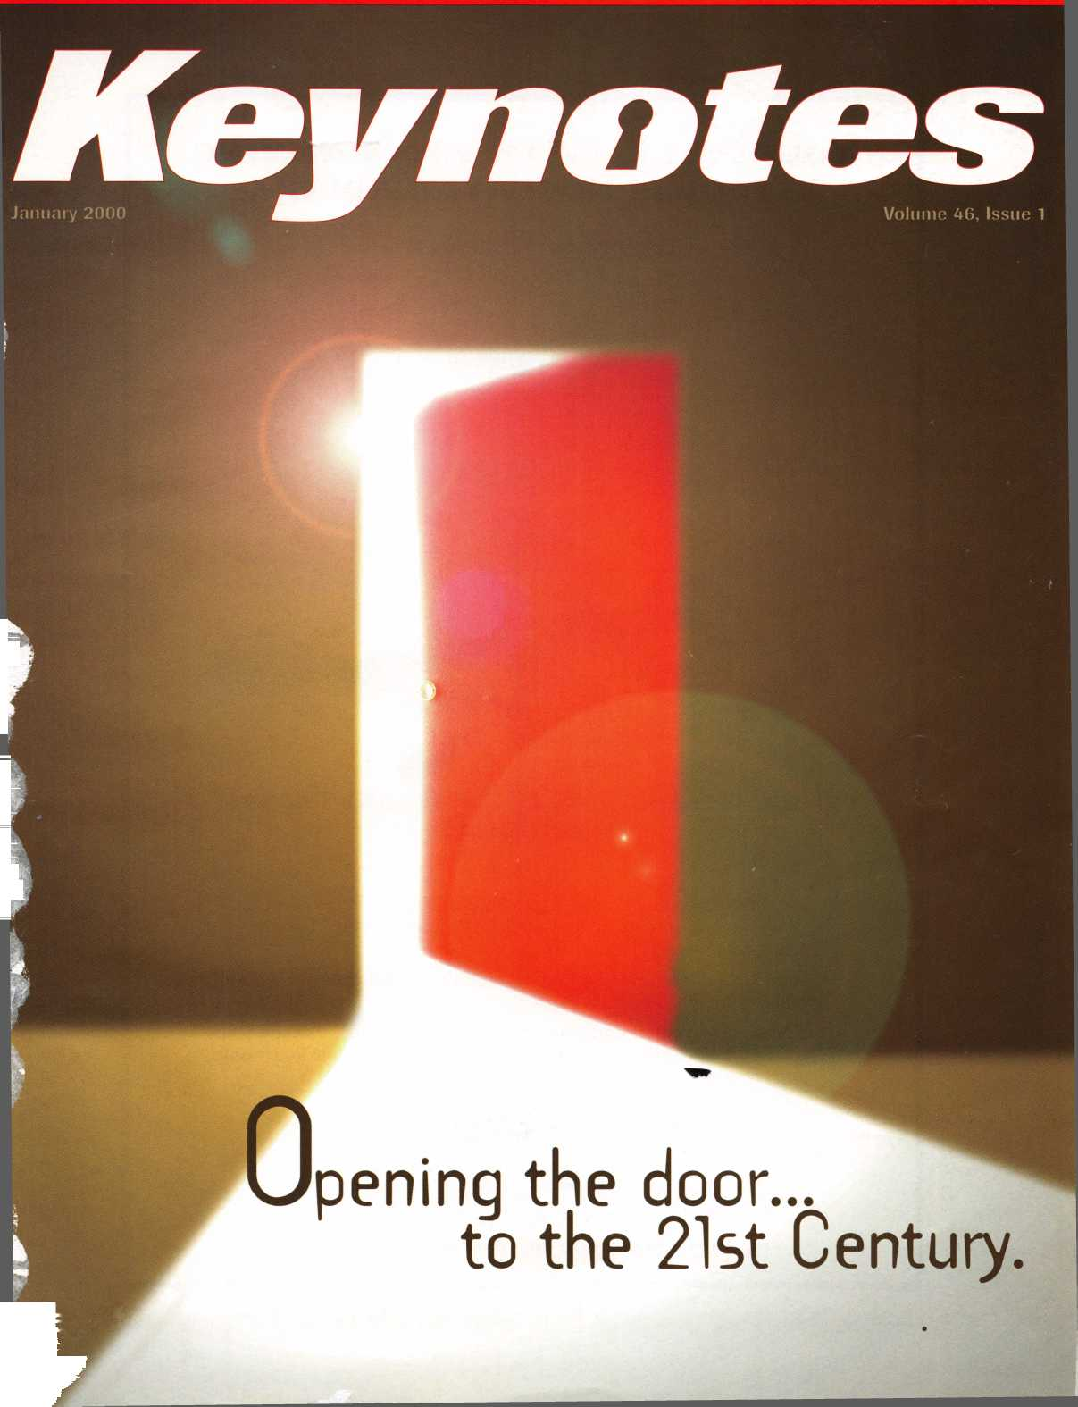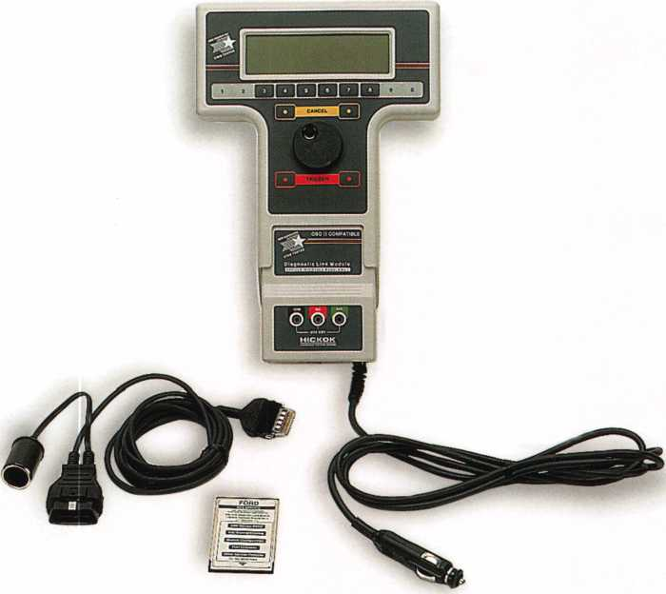

**Your FULL PATS programming**

TOOL IS NOW AVAILABLE!

INCORPORATED

Contact Hickok Inc. at (800) 342-5080  
for more information on a distributor in your area.

* Use the NGS to program keys into Ford-Lincoln-Mercury vehicles (1996 through current model year 2000) equipped with a Passive Anti-Theft System (PATS).
* The NGS kit (Model 800-8LA) contains the components to access all vehicles equipped with PATS.
* Stop sending your customers to the competition, or to the dealer when you can provide the service, make money and save the customer time.

HICKOK

**New Generation STAR (NGS) Tester**

(800-8LA)

W To navigate

W your locksmithing

enterprise into the next millennium you need the latest training, product information, and tools. You can explore the entire locksmithing

universe at one great show—ALOA 2000 in

as, Nevada

You can also beam aboard

newest attraction

**Star Trek: The Experience.** For more information visit our website at

**http:/ / [www.aloa.org/](http://www.aloa.org/)**

and plan to boldly

go to ALOA 2000.

**It’ll be here**

**before you know it**



Features

**January**

-0—

**Volume 46, Issue 1**

The Cover

What’s behind the door? New hardware and antique fixtures. Plus,informative articles on legislation, inventory and advertising your locksmith business.

Art direction/design Valerie Rowe

-4

2**|** Keynotes

President’s Journey

A new era for ALOA. A new name?

By John J. Greenan, CML

15

Arm-A-Dor Revisited

It’s four years old and still as versatile as ever! Find out why  
Sargent and Greenleafs Arm-A-Dor is a worthwhile investment.

By Don B. Dennis, CPL

19

Proving the Return on

Your Yellow Pages Advertising Investment

Don’t have a huge budget for advertising?

Maybe the Yellow Pages can help.

By Clint Pollard

{Commercial Key-in-Lever Locksets

'here’s so many on the market and each seems to have different features.

Here are some samples of the most common key-in-lever locksets,  
plus photos.

by Sal Dulcamara, CML

Antique Surface Mounted Rim Locks

They were used during the Roman Empire and are still being manufactured

today. Here are some interesting facts on these ancient locks.

By Michael Ferrill

26

Lock In on Lock Outs

Lock Out/Tag Out devices are in demand these days. Here are  
some products available from Master Lock that meet both customer  
and OSHA specifications.

By Billy Edwards, CML

28

Gettin’ The Lead Out

In California, there was legal wrangle over the lead content in keys.  
ALOA’s Legislative Manager gets to the bottom of this controversy.

By Tim McMullen

30

Padlock Inventoiy

What seems like a routine store task may be more involved  
than you’d think.

By Don Dennis, CPL

32

Legislative Comment

Industry professionals come together in Ohio to discuss  
Alarm Licensing legislation.

By Tim McMullen

January 2000

Departments

6

Core

8

Upcoming Events

10

Security Marketplace

42

Authors in This Issue

44

Back Page

34

Classifieds

36

Associate Members

39

Ad Index

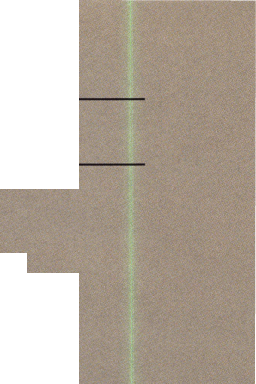

**Staff**

Executive

|  |  |  |
| --- | --- | --- |
|  | Editor | Mike Emery [keynotes@anet-dfw.com](mailto:keynotes@anet-dfw.com) |
|  | Technical Editor | David Lowell, CML, CMS david @aloa. ioffice.com |
|  | Communications/Financial Coordinator | Patanya Johnson |
|  | Editorial Advisor | John D. Cannon, CML [jdcannon@worldnet.att.net](mailto:jdcannon@worldnet.att.net) |
|  | Advertising Sales | Marvin Diamond  Native American Journal Co. |
|  |  | (706) 782-0878 |
| XI |  | [thediamonds@mindspring.com](mailto:thediamonds@mindspring.com) |
|  | Contributing Editors | Paul Chandler, CRL |
| VI |  | Claire Cohen, CML |
| j |  | Sal Dulcamara, CML |
|  | Contributing Authors | Jerome V. Andrews, CML |
|  | ALOA Professional Staff | Brian Costley, CML, CMS  Bob De Weese, CPL  Ray D’Adamo, CML  Michael A. Ferrill  James Glazier, CML  Daniel Graffeo, CRL, CMS Wayne Gurnee, CRL  A.J. Hoffman, CML  Ken Holmlund, CRL  Ray Lusk, CML  Mark Ohno  Randy Simpson, CML  Robert Stafford, CPL  Dave Thielen, CML |
|  | Executive Director | Charles W. Gibson, Jr., CAE [charlie@aloa.ioffice.com](mailto:charlie@aloa.ioffice.com) |
|  | Operations Manager | Mary May  [mary@aloa.ioffice.com](mailto:mary@aloa.ioffice.com) |
|  | Comptroller | Kathy J. Romo |
|  | Meetings Manager | Jessica Smith [jessica@aloa.ioffice.com](mailto:jessica@aloa.ioffice.com) |
|  | Government Affairs Manager | Tim McMullen [tim@aloa.ioffice.com](mailto:tim@aloa.ioffice.com) |
|  | PRP/Education Manager | David Lowell, CML, CMS [david@aloa.ioffice.com](mailto:david@aloa.ioffice.com) |
|  | PRP/Education Coordinator Chapters & Regional | Ashley Spencer |
|  | Associations Liaison | Tim McMullen [tim@aloa.ioffice.com](mailto:tim@aloa.ioffice.com) |
|  | Information Systems Manager | Randy McChristian |
|  | Receptionist | Barbara Ortiz |

Additional contact information for the ALOA Board and most Keynotes authors is available through “Locksmith Search'” on the ALOA website- [www.aioa.org](http://www.aioa.org) or by contacting the ALOA office at 3003 Live Oak Street; Dallas, TX 75204; 0800)532-2562;

FAX (214)827-18T0; e-mail [aloa@aloa.org](mailto:aloa@aloa.org).



sion Statement: The Associated Locksmiths of America, Inc. is dedicated to enhancing the professionalism, education and ethics among locksmiths and e in related sectors of the physical security industry. With approximately 10,000 members in the United States, Canada and the freeworld, ALOA is poised to members obtain the knowledge, the strength, and the confidence to perform their role in the physical security field with pride and dignity. But it is only jgh active involvement and participation that ALOA can fully achieve its potential-and can help members to achieve theirs, icies: **Keynoted** is the official publication of the Associated Locksmiths of America, Inc. (ALOA). **Keynoted** acts as a moderator without approving, oproving, or guaranteeing the validity or accuracy of any data, claim, or opinion appearing under a byline or obtained or quoted from an acknowledged ce. The opinions expressed by the authors do not necessarily reflect the official views of ALOA. Also, appearance of advertisements and new products or ce information does not constitute an endorsement of products or services featured by the Association. The Association does not accept responsibility for naccuracy of any data, claim, or opinion appearing in this publication, due to typographical errors on the part of the authors, Association staff or its agents, tor’s Note: This publication is designed to provide accurate and authoritative information in regard to the subject matter covered. It is provided and jminated with the understanding that the publisher is not engaged in rendering legal or other professional services. If legal advice and other expert itance is required, the services of a competent professional should be sought.

:hors’ Payment: Payment for eligible submissions to **Keynotes** will be based on the following criteria: topic, time spent and past contributions. Authors who lariy submit to **Keynotes** are generally paid a higher rate. The latter is especially true of authors who write to fit specific editorial needs and submit said copy **eynotes** deadlines. As a general guideline: Average payment for a 750 word, business or light’ technical article would be $200. Payment for a 1500 word article /ing significantly higher time and research efforts would be $400.

/merit will not be offered for articles submitted by ALOA employees or members of the ALOA Board of Directors (unless material is of a technical nature), or articles submitted by a company that promote that company’s products or services. ALOA reserves the right not to pay for articles submitted by an idual(s) that promote a particular company’s products or services.

claimer: The Associated Locksmiths of America, Inc., (ALOA), reserves the right to refuse any article for any reason. Additionally, ALOA reserves the right lit, amend or modify any article submitted for publication in order to preserve technical accuracy, clarity, fairness or grammatical correctness. ALOA will make )est efforts to notify the author of any changes. The extent of ALOA’s liability for any article or information contained therein will be a notice of correction or ction in the next possible issue.

lofes® (ISSN 0277 0792) is published monthly except for the combined June/July issue by The Associated Locksmiths of America, Inc., 3003 Live Oak St, is, TX 75204-6186. Telephone: (214) 827-1701; FAX (214) 827-1810; e-mail [aloa@aloa.org](mailto:aloa@aloa.org). Subscription rates for members-$15.00 per year. Second class age paid at Dallas, Texas. POSTMASTER: Send address changes to: **Keynotes,** 3003 Live Oak St., Dallas, TX 75204-6186. © Copyright 2000, All rights ved. No part of the contents may be reproduced or reprinted in any form without prior written permission of the publisher.

3oard



President

John J. Greenan, CML, CPS (773) 486-2030

Secretary

John D. Cannon, CML (703) 960-6413

Directors, North Central

Mark E. Blum, CML, CPS (517) 482-5809 Tom Ripp, CRL (608) 262-3831

Directors, Northeast

James H. Glazier, CML (301) 831-5454 John C. Magee, III

1. 845-3434 William L. Young, CML
2. ) 647-5042

Director, Northwest

Scott L. Henke, CRL, CPS (907) 248-3785

Director, South Central

Randy L. Simpson, CML (713) 780-7026

Directors, Southeast

Thomas W. Tate (850) 476-4211 Donald E. Rul6, CML (601) 324-2658

Directors, Southwest

Gordon R. Racine, CML (719) 384-4707 John A. Ilk, CRL (602) 420-2174

Director, Associate Members

Judd Penske (800) 634-5465

Trustees

Dallas Brooks

(334) 826-8990

David M. Lowell, CML, CMS

(800) 532-2562

Breck H. Camp, CML

(770) 455-6244

Edwin Toepfer, RL

(416) 225-5589

Past Presidents

1997-1999 Dallas C. Brooks 1995-1997 David Lowell, CML, CMS 1993-1995 Breck Camp, CML 1991-1993 Henry Printz, CML 1989-1991 Evelyn Wersonick, CML, CPS 1987-1989 Leonard Passarello, CPL 1985-1987 Joe Jackman, CML 1983-1985 Stanley Haney, CPL 1981-1983 Louis LaGreco, CPL 1979-1981 John Kerr, RL 1977-1979 Clifford Cox, CML 1974-1977 Charles Hetherington 1972-1974 Gene Laughridge 1970-1972 William Dutcher, RL 1968-1970 Constant Maffrey, RL 1966-1968 Harold Edelstein, RL 1964-1966 William Meacham 1962-1964 Robert Rackliffe, CPL 1960-1962 Edwin Toepfer, RL 1956-1960 Ernest Johannesen

January 2000

Keynotes

with John J. Greenan

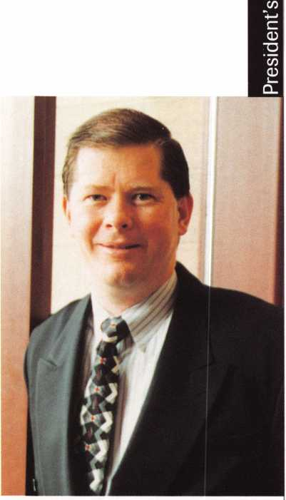

Well, its a new year, a new century and a new age for ALOA. By this, I mean that our chosen profession, “locksmithing,” has changed immensely since this association was founded. It used to be that our industry revolved mainly around locks, keys and safes. Now, we find ourselves performing an array of other tasks. From access control to auto locks to alarms to computers, we have gone beyond the realm of mere locksmithing. As technology continues to affect our industry, our daily tasks also evolve.

ALOA is changing in other ways as well. For instance, we aren’t tmly just the Associated Locksmiths of America. Considering our growing numbers in Canada, Japan, Mexico, Europe, Korea and other parts of the globe, we are a genuine inter­national organization.

So, here’s something to think about. We’re not solely locksmiths anymore, nor is ALOA limited to to the United States. Maybe we should think about renaming this organization, so that it truly reflects where we stand as professionals.

At this point, it’s just a thought, but we cannot ignore the changes that have helped us grow. Likewise, we must not overlook the alterations that are looming on the horizon.

If anything, this is good. It goes to show that we have not become professionally antiquated and that our impact has stretched across the globe. Indeed, two things to be very proud of.

Change, however, is often a difficult concept. For years, people have come to recognize the ALOA name and logo. Would modifying it be to our advantage?

Or, could this be detrimental to all of the hard work that has gone into our organization?

I would certainly like to know what the members think, so feel free to contact me ([fsl.john@mindspring.com](mailto:fsl.john@mindspring.com), (773) 486-2030, (773) 486-4268 fax) and give your feedback on the subject.

Until then, I wish all of you a happy new year and look forward to what 2000 holds for ALOA.

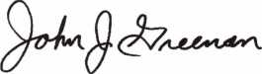

John J. Greenan, CML, CPS



Keynotes

January 1999

**Keynotes is changing!**

**Next month, this magazine will sport a new look and format! It’s all in an effort to provide ALOA members with the best means of communications possible. This is just a brief alteration to determine what kind of information ALOA members find most helpful in this publication.**

**It will also let us know what kind of format is most effective. In March, we will return to our normal format.**

**Of course, we certainly welcome all comments and questions regarding the change. Don’t hesitate to write or email us and let us know what you think. After all, this is your publication and it’s vital that we receive your feedback!**

**Send all inquiries to:**

Keynotes **3003 Live Oak Dallas, TX 75204 (214) 827-1810 fax [keynotes@anet-dfw.com](mailto:keynotes@anet-dfw.com)**

• Three’s Company

Guardian International received three awards at the First  
Alert Professional Security Systems dealer conference in Miami,  
Fla. These included the Medal of Honor, awarded to Guardians  
president and CEO, Richard Ginsburg.

Other honors included a second place finish for Dealer of the  
Year as well as an Eastern Regional Special Achievement Award.

Guardian is a provider of burglar and fire monitoring services  
including design, installation and service of security and fire  
alarm systems.

Security Conscious. Patrick Impreveduto {center), Principal ofSecaucus High School, discusses security surveillance systems with J. H. Jun (left) President of Samsung Camera, and Mike Strange, Director of Marketing. Samsung Camera donated the video surveillance system to the school.

• Samsung Goes to School

All eyes were on Secaucus High School. The New Jersey school was the recipient of a new video surveillance security system that was donated, manufactured and installed by Samsung Opto-Electronics America, Inc. The need for such high tech security tools comes at a time when a reported three million crimes occur on or near school property each year. Included in the equipment provided to the High School are indoor and outdoor ultra-low light CCD cameras, digital duplex multiplexers, color CCTV monitors and VHS time lapse video cassette recorders.

• Not a Palm Reader

Out of Great Britain comes the first open-circuit television security system (OCTV). It allows anyone with a mobile telephone and desktop PC, laptop or hand-held palm computer to transmit and receive high quality video pictures to and from anywhere in the world. This system was created by Shawley Ltd. and provides remote surveillance via the mobile phone network over any distance through a camera that can be held in the palm of a hand or fixed to a wall or ceiling in homes and offices. Authorized personnel with a mobile phone and computer combination and a PIN code can monitor at all times. OCTV can also be used with traditional wired telephone systems.



Keynotes

January 2000

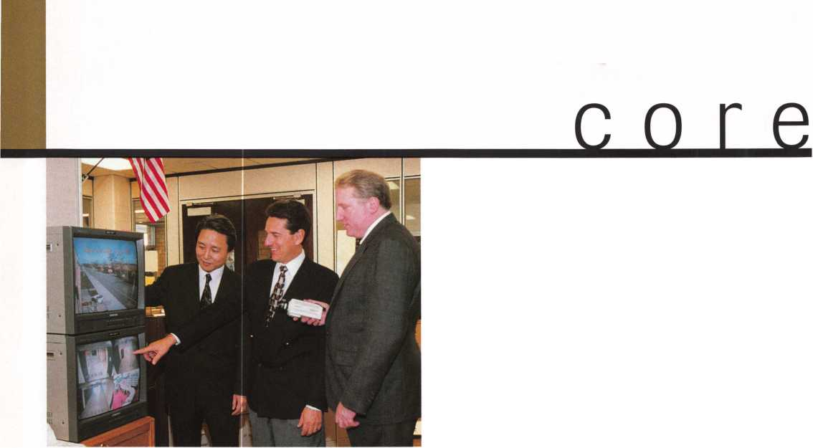

* Regions

The next meeting for the **East Tennessee Locksmiths Association** is January 15 th at 9:00 am. It will feature a demonstration of Sargent and Greenleaf’s Arm-A-Dor. For location information, call (423) 502-5397.

* Execs

NAPCO Security has named Pasquale Corte the New Regional Sales Manager for the Northern United States.

• Obituaries

ALOA bids a sad farewell to two of its valued members. Please keep the friends and families of these two individuals in your thoughts and prayers.

LeVon Blough Robert A. Westall

• PRP

CRL

**Kevin Ahrens,** Lake Zurich, IL **Rick Bridges,** Litchfield, IL

Bruce D. Colgate, **Suffield, CT** David Hallee, **Waterville, ME** Robert D. Lamothe, **Belchertown, MA** Gene Saathoff, **Litchfield, IL** Norman Schulthesis, **St. Louis, MO** Stephen Sherman, **Jamesburg, NJ** Karl Waller, **Vernon Hills, IL**

CPL

Glenn K. Ross, **Lubbock, TX**

WE’RE NOT JUST" KEYS...ANYM0RE

Key Sales & Supply, one of the nation’s largest key blanks and tool suppliers, now stocks the most popular door hardware.

Prices subject to change.

INSTOCK:

Key Blanks Key Machines Locksmith Tools & Supplies Locks of All Types American & Foreign Automobile Locks Security Hardware (Wholesale Only)

AR1-13S-1179

AR3-KN1179A

AR4-135A-1178A

B1-98M-1098M

Bs-mmtiomi

BS48DB-1098DB

B10H98LA-H1098LA

B11-098LA-01098LA

B24H98X-H1098X

B44-X98E-P1098E

B45-098H-S1098H

B4&X98J-P1098J

B47-098K-S1096K

B48-P91A-P1098A

B49-S91BS1098B

B50-P91C-P1098C

B51-S91D-S1098D

B&&B4-98X-1098X

BE2-A114A-A1114A

BN1-L54P-K1122D

BOVHL2-22B-R1003M

CQ1-41Q-1041Q

CG2-41GA-1041GA

CQ4/CQ3-41QR-1041GR

CQ16-41R-1041T

CQ17/KP1-41Y-1041Y

CG22-41RB-1041E

C01-20-1000

C03-21EB-1001EB

C07-21EH-1001EN

C010-20G-1000Q

CQ26-20V-1000V

C068-20VS-S1000V

C087-22Z2-1001EH

C08&C066-A22Z2-A1001EH

C089-A22GM-A1001ABM

C091-A22A1-A1001AH

C097-K22-1001QH

C0106/HL1-R22B-1003M

DE6-54DR-D1054K

EA1-61-1014

EA27/EA50-X61F-X1014F

EL10C1096CN

ER1-119-1119

ES8-1502

FA1-F54-10S4WC

FR2-L54G-L1054Q

H26-127ES-1127ES

H27-127DP-1127DP

H50S27-S1167FD

H51-P27-U87FD

H54-PS23F3-1184FD

H60-1190LN

H03-170-1170B

HR1-X61FR-1014C

IN1-54F-1054F

miN20-X54K-10M

IN8-L54B-L1054B

IN18-XS4F-X10S4F

IN28-54FN-1054FN

IN29-1054UN

IN33-54UT-I054MT

IN35-1054DL

K2-79HK-10798

KW1-S4KS-1176

LI-35’1004

L4-35A-1004A

MI-92-1092

M2-92B-1092B

M4-U92A-1092V

M10-92N-1092N

M11-92T-1092H

M27/M1642NR-1092NR

NA12-174BN-1069LA

NA24-1069LC

NA2S/NA7FN174D-R1064E

NH1-N102-1177N

RA3-998-S1970AM

RA4-99A-1970AM

R01-62-1069

RO3-174J-1069N

RU1-55-1011

RU4-55P-1011P

RU16-57PA-A1011P

RU4547-1D-1011D1

RU4&A57-1DA1011D1

SI-48-1009

S340-1010

S4-050-1010U

S6-049KM-FI1007KMA S16-49KM-N1007KMB S22-043LA-01007LA S22-1/2-43LA-1007LA S32-48KMR-N1007RMB

1. 61S-1010N
2. 51SA-L1010N SC1-145-1145 SC4-145A-1145A SC6-307A-1307A SC7-145FS-1145FS SC8-145ES-1145E SC9-14SE-A114SE SC10-145F-A114SF SC20-145L-A1145L SC22-307W-1307W SE1-102-1022

STOCKING DISTRIBUTORS FOR:

Abus Lock Co.

Alarm Lock American Lock Co.

Arrow Lock

Auto Security Products

SK1-R21EN-R1001EN

T3-111E-1141E

T7-111GE-1141QE

WEI-133-1123

WK2-175W-117SN

WR354WB-1064W8

WR4-54WA-A1064WB

WR5-64WC-N1054WB

WRB/FA2-F54A-A1054WC

XL7-XL16-1180S

Y1-14-999

Y1E-E14-999N

Y2-14A-999A

Y3-14YM-C999

Y4-12GM-998

Y6-7X-997X

Y11-7NX-01122

Y12-07NX-01122A

Y13-R7NX-01122R

Y14-R07NX-01122AR

Y52-7E-997E

YS4-07E-0997E

Y103-07B-01122B

Y149-S19-S1770U

Y152f19A-P1770U

Y220-X14S-999B

CCL Security Products Chicago Brinks Safes Detex

Don-Jo Mfg Co.

Dorma

EMTEK

ESP Lock Corp.

Fort Lock Corp.

Fremon Mfg Co., Inc.

KES HPC, Inc.

Hudson Lock Ca ILCO Unican Corp.

KABA

Keedex

Keystone Novelty Co.

Key Systems KSP

KwOtset Hardware Group LAS

Lucky Line Products Corp. Mag Engs. & Mfg Co., Inc

Send in order or  
request order  
form.

1-800-445-KEYS (5397)  
313-931-7720

Fax: 1-800428-KEYS (5397)  
Local Fax: 313-931-7758  
9950 Freeland  
Detroit, Michigan 48227

January 2000

***Keynotes***



IJpnnming

Events



[Dept)

JANUARY

8

Ace Classes

Wyoming Locksmith Association Casper, WY

Contact: Gene Fieck, CPL (605) 642-4542 (605) 642-8946 fax

14

**f/** ALOA PRP Sitting Dallas, TX

Contact: David Lowell, CML, CPS (214) 827-1701 (214) 827-1810 fax

15

Investigative Locksmithing II Class Richmond, VA

Virginia Locksmiths Association Contact: Troy Miller (804)977-5397

16

Ace Classes

Nutmeg Chapter of ALOA Middletown, CT Contact: Bob Stafford, CPL (860) 768-7917 (860) 768-7801 fax

22

Investigative Locksmithing II Class Towson, MD

International Association of Investigative Lockmsiths Contact: Don Shiles

(800) 598-9491 Lenny Podgorski (410)515-2934

24-27

SiteLine Certification KeyMark Certification Biaxial Certification Salem, VA Medeco

Contact: Lisa Burton (540) 380-1826

28

Biaxial Certification Fargo, ND Medeco

Contact: Lisa Burton (540) 380-1826

mRMABW

5-6

23rd Annual Antique Lock Show Arcadia, CA

West Coast Lock Collectors Contact: BobHeilemann (310) 454-7295 voice mail (310) 230-3004 evenings only Contact: Doug Huse (626) 797-1610

9-10

Biaxial Certification KeyMark Certification Houston, TX Medeco

Contact: Lisa Burton (540) 380-1826

9-13

TLA Annual Convention and Trade Show PRP Sitting Houston, TX

The Texas Locksmiths Association Contact:

Registration info:

Jim Hetciller (830) 606-1727 Exhibitor info:

Robert Hernandez (210)433-5397 General info: (877) TLA-INFO

23-26

Svc Coordinator Training SiteLine Certification Biaxial Certification KeyMark Certification Kansas City, MO Medeco

Contact: Lisa Burton (540) 380-1826



***Keynotes***

January 2000

10

**ft\*** ALOA PRP Sitting Dallas, TX

Contact: David Lowell, CML, CPS (214) 827-1701 (214) 827-1810 fax

12

**(/** ALOA PRP Sitting Rosemont, EL Clark Security Products Contact: Ron Cooling (858)974-5273 (858) 974-5284 fax

1. 16

SiteLine Certification Biaxial Certification KeyMark Certification Salem, VA Medeco

Contact: Lisa Burton (540) 380-1826

1. 16

ISC Expo Las Vegas, NV (800) 840-5602 isc.reedexpo.com

1. 19

Trade Show & Security Conference Troy, MI

IDN Hardware Sales, Inc

Contact: Fred Strasberger or Bonnie Weston

(800) 521-0955

1. 19

Buyers Trade Show & Classes St. Petersburg, FL Southern Lock & Supply Co.

(800) 282-2837 [www.southemlock.com](http://www.southemlock.com)

2001

MARCH

|  |  |
| --- | --- |
| 26 | 9-10 |
| ^ ALOA PRP Sitting | ISC Expo |
| Hattiesburg, MS | Miami, FL |
| Lou-Miss Locksmith Association | (800) 840-5602 |
| Contact: John Kiick, CML | isc.reedexpo.com |
| (601)649-5426  (601)649- 5426 fax | 12 |
| APRIL | f/ ALOA PRP Sitting Dallas, TX |
| 2 | Contact: David Lowell  (214) 827-1701 |
| ALOA PRP Sitting | (214) 827-1810 fax |
| Oakland, CA  Clark Security Products | JUNE |
| Contact: Ron Cooling  (858)974-5273  (858) 974-5284 fax | 21-22  ISC Expo |
| 6-9 | Chicago, IL  (800)840-5602 |
| MLANJ Annual Convention | isc.reedexpo.com |
| \^T\ Ace Classes  Master Locksmith Association of New Jersey Somerset, NJ | JULY |
| (973) 267-8884 (973) 538-2248 fax [www.mlanj.org](http://www.mlanj.org) | 24-30 |
| 14  rjr ALOA PRP Sitting | ALOA 2000 Security Expo Ace Classes ft* PRP Sitting  Las Vegas, NV |
| Dallas, TX | (214) 827-1701 |
| Contact: David Lowell  (214)827-1701  (214) 827-1810 fax | AUGUST |
| 19-23 | 28-31 |
| Easter Convention | ISC Expo |
| Birmingham, England | New York, NY |
| Master Locksmiths Assoc, in the UK | (800)840-5602 |
| Contact: Mick Friend | isc.reedexpo.com |
| [Mick@locksmiths.co.uk](mailto:Mick@locksmiths.co.uk)  MAY  1-6 | SEPTEMBER  11-14  ASIS Show |
| SAFETECH 2000  PRP Sitting | Orlando, FL |
| Birmingham, AL | (703) 522-5800 |
| (214)827-7233 | [www.asisonline.org](http://www.asisonline.org) |

28-April 1

MLANJ 2001 Annual Convention Somerset, NJ (973) 267-8884 (973) 538-2248 fax [www.mlanj.org](http://www.mlanj.org)

JULY

16-22

ALOA 2001 Security Expo Baltimore, MD (800) 532-2562

2002

JULY

22-28

ALOA 2002 Security Expo Rosemont, IL (800) 532-2562

Indicates ALOA ACE Class Indicates PRP Sitting

January 2000

Keynotes i-

Security

Marketplace

HID Corporation

Available from HID is ProxTrak, asset tracking products. They can be integrated seamlessly into most existing access control systems. HID ProxTrak products offer enterprise security directors a rapidly dependable electronic property management solution they can provide to their finance and IT peers. This product line includes asset tags and readers that share HID’s popular proximity identification technology. Because the ProxTrak products have been designed with a Wiegand output, which is standard for many access control systems, no additional wiring or hardware is required to begin to take advantage of the basic benefits of asset tracking technology. Enterprises need only install desk/wall-mounted ProxTrak MaxiTrak readers in either a new location or in a retrofit fashion using existing wiring. The MaxiTrak reader is capable of reading both proximity cards and ProxTrak asset tags. HID asset tracking tags already have been embedded in over five million IBM portable computers, desktop computers and servers.

Also from HID are eProx Products. eProx proximity technology is expected to increase the speed of verification times while making biometric readers more accurate and reliable. The eProx-enabled biometric readers are compatible with HID-based card access systems. The dual technology readers enhance the security of highly sensitive areas without requiring additional systems or infrastructure. eProx biometric readers feature dual identity verification capability to ensure security.

HID Corporation 9292Jeronimo Road Irvine, CA 92618-1905 (949)598-1600 (949) 598-1680fax

Jet

Ford transponder keys for the 2000 models and for all prior years can now be made without an original key. The NGS-1 plugs into the vehicle and will create a new key. Five free Ford H72-PHT Transponder Keys are included with the NGS-1 and is now available from Jet distributors. Also from Jet is the ETD-NGS-1S, a combo package for all Ford automobiles and other cars equipped with Transponder



programmable keys. The ETD-NGS-1S comes with 10 Ford and five other Transponder Keys. When purchased separately, either the ETD-1S or NGS-1 comes with five keys each.

Jet Hardware Manufacturing Corp.

800 Hinsdale St.

Brooklyn, NY 11207

American Door Services, Inc.

American Door Services, Inc. has opened an online catalog store with secure credit card ordering and specializing in commercial door hardware. The catalog features hinges, locks, closers, stops, accessories panic exit devices and many other items. One of the features of this site is that it offers detailed descriptions and specifications for the items listed.

American Door Services, Inc. wunv.commercialhardware.com (888) 421-4432

Maries USA

Marks USA is offering a full line of ornamental security storm doors from Marks USA. A new, four color brochure assists buyers in selecting mortise locksets for ornamental security storm doors. Standard and thin line versions are available featuring screwless knobs and levers, proprietary no droop lever springs, cylinder collar security inserts and high strength solid steel hubs. **Marks USA**

5300 New Horizons Blvd.

Amityville, NY 11701 (631)225-5400 (631) 225-6136fax [nancy@marksusa.com](mailto:nancy@marksusa.com)

NAPCO

NAPCO recently introduced the “Gemini EZM-4/8", a new zone expansion module for its GEM-P816 and GEM-P1632 Control Panels. The “Gemini EZM-4/8" expands the capacity of both the P816 and the popular GEM1632m increasing their eight on-board zones in selectable increments of four or eight zones.

NAPCO

(800) 645-9445 ext. 64

Schwab Corp.

Schwab introduced a 20" Hero file, a fire- protective file. The Hero holds up to 15 inches of letter-sized or 12 inches of legal­sized documents in each drawer. The addition of a Schwab Media Cooler, which fits in either drawer, diversifies storage to include the fire-protection required for sensitive computer media. Insulite a chemically dry insulation well known for its efficiency, provides the Hero with UL Class 350-1 Hr. fire protection. Framed by the Hero’s seamless steel body, Insulite is also used between the drawers making each one independently fire resistant. Steel-lined drawers add further protection by preventing entry into a locked drawer from an unlocked compartment, and also keep insulation from dusting your records. The Hero’s exterior meanwhile, has a professional finish and features recessed handles. A key lock also comes standard.

Schwab Corp.

P.O. Box 5088 Lafayette, IN 47903-5088 (765) 447-9470 (765) 447-8278fax

Sensormatic Electronics Corporation

Sensormatic Electronics Corporation recently introduced Video Server. Video Server is a browser-based transmission product that delivers video images and alarm notifications over the Internet, intranets, ethemet networks or dial-up networks.

Using a TCP/IP network connection, the product makes video surveillance images available to any authorized user, anywhere. The product will ship in Spring 2000. Video Server will take existing Sensormatic CCTV systems and turn them into open systems where images and alarms can be accessed via a PC on the network using a standard browser. Not only will security personnel be able to access video, but network access privileges can be set up so that other management will have access to the video. **Sensormatic Electronics Corporation 951 YamatoRoad PO Box 310700 Boca Raton, FL 33431-0700**

*Keynotes*

December 1999

Sieveking Products Co.

Sieveking Products Co., announced the addition of the “Key-Scope” to its growing line of locksmith tools. This wafer lock reading tool incorporates features not found in any other scope. Key-Scope has a new variable intensity high output light. The longer wafer depressor allows the locksmith to read wafers in deeper keyways. There are two viewing lenses on Key-Scope. One lens is short focus, for standard keyways, the other is long focus for deeper keyways and safe work. Used together, the Key-Scope lenses ADD, to give a higher magnification, ideal for reading those hard to see impression marks. A padded hard-shell is included. Sieveking also announced changes to the Squeeze-Play hollow metal door mortising tool. The tool will mortise 90-percent of the edge seamed hollow metal doors found in residential and commercial markets. Improvements made to the automatic center punch feature will increase the depth of the punch marking. Squeeze-Play automatically locates and punches the locations of the square face bolt mounting screws. Squeeze- play will mortise 1 3/4" doors, and mark mounting locations for 2 1/4" x 1" and 2 1/4" x 1 1/8" square face bolts, eliminating the need to cut the door or use internal bridges. The mortise is made with no loss of the doors structural integrity.

Sieveking Product Co.

3437 South Bend Road Rockford, IL 61109 (815) 874-4030 (815) 874-5713 fax

Trine Products Company

Trine Products Company recently issued an informative booklet and poster on EN Fire Rated strikes and accessories. The brochure contains photos and relevant data on all EN Strikes. It also includes a cross reference chart and information on Trine s new EN-LB Sensor, the optical IR accessory that confirms positive latching of a lockset within an EN Strike. The 26" x 32" poster can be mounted in a warehouse or showroom where it can be referred for detailed information. It contains descriptions, templates, compatible lockset

data and additional information to determine the specific strikes suitable for certain applications.

Trine Products Company 1430 Ferris Place Bronx, NY 10461-3699 (718) 829-2332 (718)829-6405 fax

Zero International

Zero Internationals Model #770 acoustical head-and-jamb door gasket provides engineering and design features to accommodate the needs of acoustical engineers and specifiers. Secured directly to the door jamb, the gasket forms a seal of compressed, sound absorbing neoprene as the door is closed. Zero s Compress-O-Matic design allows optimal adjustment under field conditions for unsurpassed preservation of a doors sound ratings. Using the #770 with a metal cased-opening frame

eliminated the need for an additional frame stop, thus minimizing the undesirable projection into the door opening. Specifiers can achieve the same cased opening profile and coustical performance for all sound-rated openings including those with fire rate walls.

Zero International, Inc.

415 Concord Avenue Bronx, NY 10455-4801



**ML AM 2000** Annual Convention

April 6th thru April 9th Somerset, New Jersey

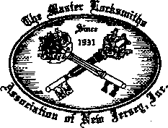

For More Information:

PO Box 2441, Morristown, NJ 07962-2441 Phone 973-267-8884 Fax 973-538-2248

Or visit our web site at[www.MLANJ.org](http://www.MLANJ.org)

December 1999

***Keynotes***

Applicants

For Membership

***The following applicants are scheduled for clearance as members  
of ALOA. The names are published for member review and comment  
prior to February 1, 2000, respectively, to ensure applicants meet standards  
of ALOA’s Code of Ethics. Protests, if any, should be addressed to the  
Membership Department and must be signed. Active Membership applicants  
(AJ have worked in the industry two or more years. Allied Membership  
(ALJ applicants are not locksmiths, but work in a security-related field.  
Apprentice Membership (AP) applicants have worked in the industry  
less than two years. J***

|  |  |  |
| --- | --- | --- |
| Clearing February 1: | MASSACHUSETTS | WYOMING |
|  | Ware | Casper |
| USA | Mark R. Paquette | James E O’Grady |
|  |  | Gillette |
| ALASKA | MISSOURI | Dave Lueras |
| Wasilla  Michael J. Cucullu | St Louis  Norman C. Schulthesis |  |
|  | West Plains | CANADA |
| ALABAMA  Guntersville  Cecil Bradford Jr. | Jill E. Rich | Edmonton |
| MISSISSIPPI | James S Walker |
| ARKANSAS | Quitman |  |
| Springdale | Rickie D. Ellard | BRITISH COLUMBIA |
| Will Dunaway | NORTH CAROLINA | Chilliwack  Douglas R Linley |
| CALIFORNIA | Concord |  |
| Navato  Mike D. Rinkor | Jeffrey L. Stone |  |
| San Francisco  Antonio M. Gonzalez | NEW HAMPSHIRE | UNITED KINGDOM |
|  | Hanover  Tracy A. Stone | London |
| FLORIDA |  | Michael Cornette |
| Boynton Beach  Robert Stephens  Saint Petersburg  William Cocker, Jr.  Tamarac  Christopher Dirocco | NEVADA  Las Vegas | Surrey  Stefan McMahon |
| Earl E. Ecton |
| PENNSYLVANIA |  |
|  | Marienville |  |
| GEORGIA | Robert Renaldo |  |
| Atlanta  Mark D .Taylor |  |  |
| Macon | TEXAS |  |
| Travis E. Hunt | Katy |  |
| Smyrna | Gilberto Royo |  |
| Ted D. Cheek | Waxahachie |  |
| Warner Robins | Jerry N. Cox |  |
| Richard H. Tillman | VIRGINIA |  |
| IDAHO | Rixeyville |  |
| Osbum  Steven D. Gilseth | Gary D. Quick |  |
| INDIANA | WASHINGTON |  |
| New Albany  Michael K. Yarberry | Longview  Daniel 0. Moscon |  |
| KANSAS | WISCONSIN |  |
| Topeka | Stanley |  |
| Dana R. Hall | David Straszkowski |  |



Keynotes

January 2000

“If you want to study for the CPS test,

you need this book.

Without that book, I wouldn’t have my certification.”

-Dennis Johnson, CPS  
Aurora, Illinois

"Mike's new book is very  
consistent with the study  
information required to pass the  
SAVTA/ALOA CPS certification  
test. I wouldn't have passed  
without it. *A tremendous  
resource for today  
and tomorrow..."*

-John T. Grist, CML, CPS  
North Georgia Security

"The Safe Technicians Reference Manual by Mike Oehlert ranks among the best technical reference and learning aids you will find in the safe and vault industry. It contains page after page of essential information and easily understood illustrations. Besides answering most of the questions commonly asked by technicians new to the field, Mike has also included plenty of information experienced technicians will find useful."

-Ken Dunckel Pacifica, California

—►Over 600 Illustrations.-*—

320 pages. Only $135.

What are you waiting for?

To order, call 800-532-2562. Allow 3 weeks for delivery.

All major credit cards accepted; or make check payable to ALOA.

The Safe

Technicians  
Reference Manual

First Edition

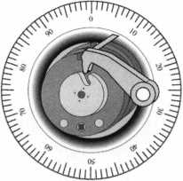

Heavy Metal.

Safe and vault technicians are not strangers to the concept of how to make large metal objects rock and roll. So what better place to hold the last safe and vault trade show of the millennium than The Steel City-Birmingham, Alabama?

From manufacturers' seminars, to education, to demonstrations and more, SAFETECH2000 is your best opportunity to prepare yourself for your future.

While you're there you can enjoy the city known for its industriousness, as well as good ol' Southern hospitality. Tour the Sloss Furnaces, the Mercedes Benz factory or any of a number of museums. You can also explore the richly wooded foothills and mysterious caverns of the Appalachian Mountains.

Join us May 1 through 6 and we're sure you'll agree-Birmingham, and SAFETECH2000 rock!

For more information call

214.827.7233,

or visit our website at

[www.savta.org](http://www.savta.org)



SAFETECH2000  
WE'VE GOT THE WORKS

**Revisited**

Arm-A-Dor arrived on the market in 1996, which now makes it four years old. I am finally beginning to see more and more of them in the market place with some very happy owners. I can’t believe that it has taken so long for the product to be seen in any good numbers in my area of the country. The only negative mention by any of the locksmiths that I have heard has been the initial cost. I want to take a look at the cost and what I have found in the field. Let’s start with the cost issue.

Arm-A-Dor has a suggested manufacturer’s list price of about $750. The first concern in dealing with the cost is with its comparison tcfother devices that range from $150 to $350. These are exit paddle devices and some bar devices that are built with the same intention that the developers gave to the Arm-A-Dor. They all have

the capability of giving off an audible local alarm signal and are used on rear exit doors. So why pay the price? I think we will find our answer in how and when we get paid as locksmiths and in the quality that our customers are lookingfor^S

I have used all of the devices on the market. I’ll not go into manu­facturers here since you folks know the list of devices. They all have 1 their place depending on how much the customer is willing to pay and how the customer’s intentions need to be fulfilled. If the door in question has high traffic and many years of dependability are required then Arm-A-Dor must be a consideration. Arm-A-Dor was built to take the abuse so long as the door can maintain its integrity of the assaults. Yes, these assaults are dealing with burglary but also I am speaking of employee usage. I am not so certain that the employee

January 2000

Keynotes



Emergency Ew • PUSH

**SAUDA DE EMERGENCE**

***Keynotes***

January 2000

**Now clearly seen, the locking roller arm is mated to the frame directly without the strike plate. This will cause excessive wear on this end of the arm.**

**This is an example of what not to**

**do! As you can plainly see, the**

**CVS hired installer neglected to install the strike plate and the**

**with alarm Arm-A-Dor.**

**release bracket for this automatic**

**Another clearly seen mistake is in the bump rod. It does extend These are the missing pieces. The strike is on the left and the**

**behind the jamb for security but jt has been lengthened and is release bracket, which comes into contact with the bump rod,**

**activated by the cinderblock interior wall. It will eventually poke is on the right a hole or indention and need to be properly attended to.**

**This is the retracting roller arm**

**that locks behind the doorjamb.**

**A screwdriver is representing the door. This is one of several configurations that are available for the bracket arrangement. The panic bar of the Arm-A-Dor will attach on the right side of the picture where the bolt and sleeve are joining the brackets.**

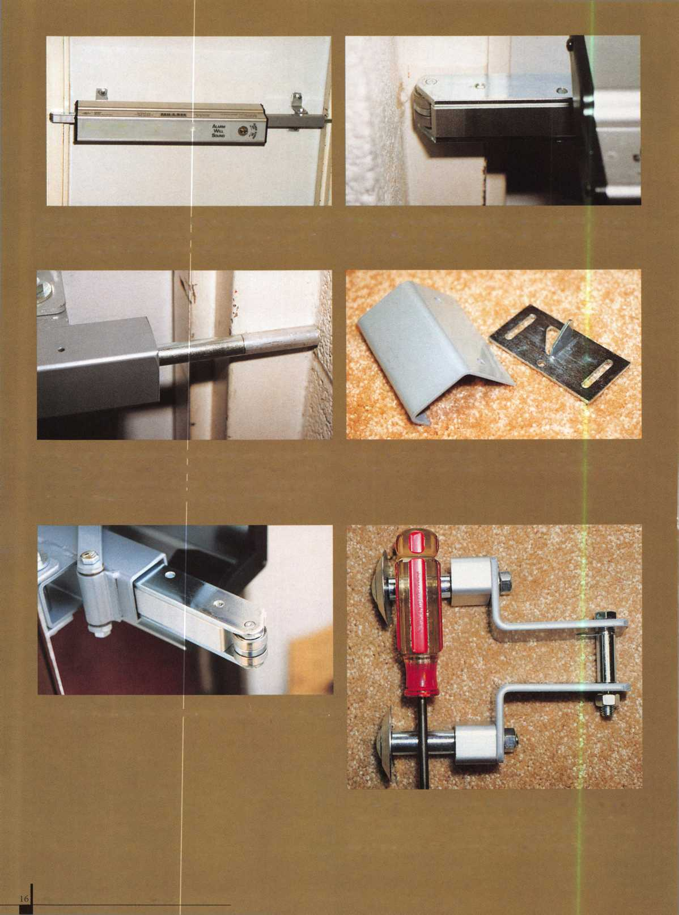

**When the outer shell of the Arm-A-Dor is removed a circuit board reveals the LED and the pin block (in blue) that allows for the different modes of alarm signals. On the left side of the photo you can see the switch that activates the alarm when the bar is depressed. The lever that releases this switch is not veiy clear but lies between the black patch and the switch.**

**Here we see a mounted cylinder (1 1/8 inch mortise). The key is turned moving the slide and holding the electronic switch in a depressed or armed position. The key returns to a neutral position to be extracted leaving the switch depressed. Once the alarm is sounding, using the key to move the switch to the open position will turn off the system. Also note the screw on the right side. It holds fast a plate that secures the cylinder in place. Even once the cylinder is secure, it may appear to wobble in the fixture. This is not a problem.**

abuse is not more debilitating than what most burglary attempts would render. Arm-A-Dor was also built for meeting all the standards of Federal and States laws without any exceptions or excuses. In checking my work receipts and records, I find that over time each alarm device that I have installed, that is used frequently and maintained, will earn between $400 to $900 dollars during its lifetime. It all depends on how much abuse the device receives.

I have one account that keeps misplacing the keys that open the battery compartment. Each time I go out and make a new key by impressioning, they hand me $85. That is the trip charge, the key, a duplicate and to lubricate the device for better operation. Since this happens every year to year and a half, I figure that over the past seven years I have made, including the original installation, somewhere in the neighborhood of $1030 off this customer. The device is on its last leg and within a year, I’ll take this analysis to the customer. They might purchase an Arm-A-Dor. It will be very easy to make this sale since there is also new CVS Pharmacy right next door and they are putting them on all of their new stores. The Arm-A-Dor has very few problems that face it. The installation instructions are a bit confusing but the installation is quite straight forward with no particular main­tenance required other than battery replacement over the years to come. I figure that I’ll not be losing any money since all of the money will come in up front. That will save me time from the yearly service routine. Investing the money, I’ll have interest dollars in my pocket with time to sell more security somewhere else! I might also add that this lack of needed service would only enhance one’s reputation for quality work.

I think it is important to think of the Arm-A-Dor as an exit device for out-swinging doors. Yes, it is also an alarm-sounding device but essentially, it comes to the market as an exit device. Once you have decided, in conjunction with the customer, that the device is needed, the next step is to see if the door and jamb are in proper working order and if the customer wants an alarm capability. You need to inspect the door for structural weaknesses. Inspect the frame for integrity. Are the hinges secured properly and in good working order? Whatever the particulars may be, you need to price the job in such a manner that the repairs of the faults take place before you install the Arm-A-Dor. This should be the case no matter what kind of device you are installing. Fix the door first and the device will last longer and work better. Besides, your price will probably be less than that of a door company leaving the customer amiable to your proposal! The Arm-A-Dor, installed properly, is one of the smoothest working devices that I have ever seen.

Should the customer also need the Arm-A-Dor to signal the building’s alarm system, an alarm accessory kit (P/N A103-002) can be added. This kit contains a switch that when the bar is pushed it presents an open connection to the alarm panel of the building’s alarm system. The alarm accessory kit can be added to all of the models of the Arm-A-Dor.

There are several models that are produced. There is an automatic device, which means that when the door is shut, the device will auto­matically lock behind the door’s frame. There is also a manual device. The manual means that once the door is brought into the frame, the bar must be pulled into the locked position. Both of these models may also be purchased with an audible alarm built into the device. The alarm sounds with a dual piezo horn measuring 95 decibels at 10 feet. You can also buy the alarm accessories kit for making the connection to the local alarm system. I should also mention here that there is a low profile kit (P/N A106-002) that can be purchased. This kit allows you to make an installation on a frame that exceeds that

January 2000

Keynotes

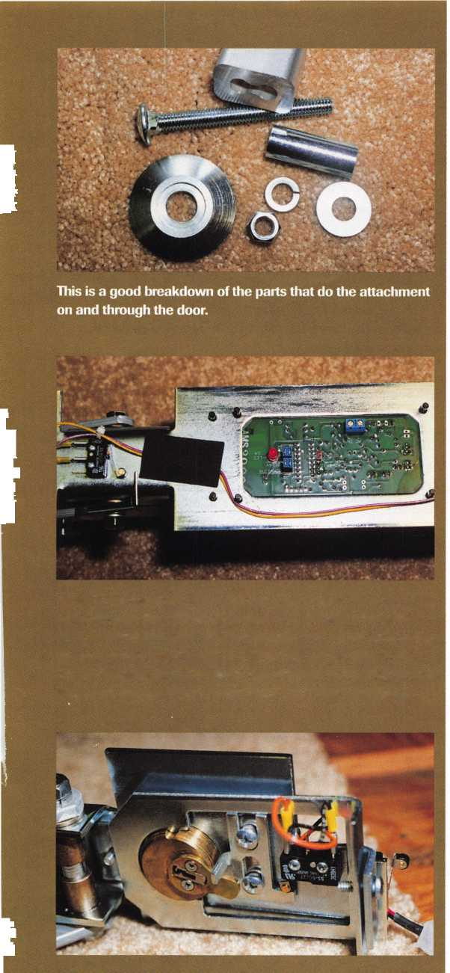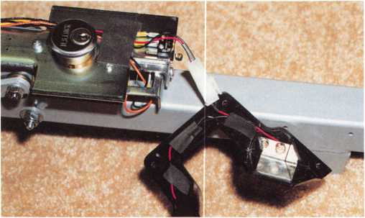

This is meant to show the battery compartment. Only one side of the end cap can be clearly seen where a battery fits. There are two batteries required. One for each side of the end cap and they are supplied with the device.

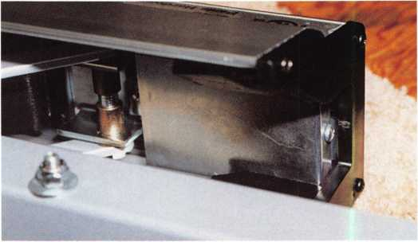

This photo shows the end cap the houses the batteries and the chrome cover that closes in the cylinder. To access the key cylinder the black end cap must be removed as well as the chrome cove and screw.

standard frame styles. For double doors there is yet another kit (A106-001) that helps to simplify that circumstance.

There are several settings that can be used when activating the Arm-A-Dor’s alarm. When you install the two required 9-volt batteries the device will beep 4 times. This tells you that the device is “alive” and ready for activation. Turn the key to the armed position and 4 more beeps will sound. After a wait of 20 seconds, the red LED located in the middle of the push bar will begin to flash every 10 seconds. By removing a jumper from the circuit board, you can change the 20-second time wait to instantaneous. When the device s bar is pushed open, the alarm will sound and will not turn off until the key is used. Then the door must be closed and by using the key, rearm the device.

There is also a reminder alarm so the device will no go unattended. Once the door is shut and the bar is locked into the frame, the alarm can beep every 15, 30, or 60 minutes as a reminder to rearm the device. It can also be set not to remind you. All of these settings are again accomplished from the circuit board.

One more option is available. There is a nuisance alarm. If enabled from the circuit board, the nuisance alarm will provide short alarm beep when the exit bar is depressed or bumped for less than 2 seconds. If the bar is pressed for longer than the two seconds, the alarm will sound requiring a key to turn it off and reset.

If I were to try and give a few tips, they would be simple. The critical part of the installation is in the measurements. I have found that in being certain in my installation efforts, I install a furnished template that is the width of the door and frame with masking tape.

I then assemble the entire device off the door. With the help of a second person, the door is set into the jamb and the device is set to the door over the template. The Arm-A-Dor weight about 23 pounds assembled and requires the help of a second person for a depression of the bar to take place. If everything matches and the device can be depressed properly, then the holes as drilled. This is a way to make certain before any damage is possible to the door. The following is taken from the S&G instruction booklet.

“Arm-A-Dor is designed for door frame widths of 36 inches to 48 inches and jamb depths of 4 3/4 inches to 12 3/4inches.”

A The standard mount assembly is designed for doorframes up to 48 inches width and a 5 3/4 inches jamb depth.

B For a jamb depth of 4 3/4 inches, use the four shorter door brackets and door spacers, and the 3 1/2 inches carriage bolts.

C For a jamb depth of 6 3/4 inches, use the standard door brackets and door spacers, and the longer carriage bolts.

D For a jamb depth greater than 6 3/4 inches, use the four shorter door brackets and the Low Profile Kit to install your Arm-A-Dor.

Once you understand these measurement concepts the rest is very easy. I did find the instruction booklet confusing in certain areas. The booklet is being revised as of this article and will be available with the purchase of new devices soon. You should allow about three hours for your first installation and that will shorten to about two hours thereafter.

I have seen several alterations to the installation directions. Most of these have been witnessed at my local CVS pharmacies. I am finding that the strike plates are not being used. The release brackets are also missing. The installers are extending the extension rod on the automatic version and instead of having it butt up against the release bracket it is hitting the concrete or cinderblock wall just outside of the frame. This will become a service problem in the future as the extension rod pokes a hole into the wall. Since the release bracket is not an after-market single item purchase, we will probably have to make an “L” bracket to attach to the frame after shortening the extension rod to a proper length for a solution.

I have also found that the battery replacement is a problem. This is not a device problem. It is a human problem. Folks will not check the devices. I recommend that since most customers change batteries in their smoke detectors twice a year, with the time yearly changes, that you try and convince them to do the same with the Arm-A-Dor.

I am finding the Arm-A-Dor is providing secure, problem free service. It is giving us a quality that is far superior to its competition. With the five year limited warranty still running on all of the current units in the field, I see nothing that can stop the success of this product other than faulty installation work.



Keynotes

January 2000

PROVING THE RETURN ON YOUR YELLOW PAGES ADVERTISING INVESTMENT

By Clint Pollard Executive Vice President - Marketing Yellow Pages Publishers Association

Whether your locksmith business is large or small, you probably don’t have a huge advertising budget. But, since in most cases, you have to advertise in order to succeed and grow, you probably rely heavily on two old standbys: word-of-mouth, and The Yellow Pages advertising.

While you can certainly encourage your customers to pass along a good word about your business, ensuring that they do so and quantifying the results of word-of-mouth advertising is difficult at best. On the other hand, proving the value of your The Yellow Pages investment can be quite easy. It’s also invaluable, especially when nearly 17-billion references are made to The Yellow Pages directories every year—that’s 1.7 times every week for the average American.

And, what’s more, as The Yellow Pages Publishers Association (YPPA) begins its second year of a $24 million national advertising campaign, consumers will see The Yellow Pages as an indispensable source of information and creativity, a place where they can turn to get new ideas, dramatically affecting how they use this invaluable marketing tool. The Yellow Pages industry expects that the national advertising campaign and the resulting repositioning of directories will have a profound impact on businesses like yours.

Return on investment (ROI) can be more simply described as a measurement of how well your advertising is working.

But, how do you determine your ROI and turn your advertising dollars into customers and profits?

The best way to determine your ROI is to follow this simple seven-step process, a process that will show you exactly how to measure the effectiveness of your advertising (see list at right.)

Let’s use an example with some figures.

Say your business receives 100 calls in a month’s time and that your call conversion rate is two. Take 100 and divide by your conversion rate (two) to get 50 (the number of sales attributed to The Yellow Pages customers). If your average gross profit per item sold is $50 and you multiply that figure by the number of sales made to The Yellow Pages customers (50), you arrive at a total gross profit of $2,500.

If you determine that you spend $600 per month on your The Yellow Pages ad and subtract that number from your total gross profit, you will arrive at your net profit gain.

If these were your numbers, you would have received $1,900 per month in gross profit over and above the $600 investment you made in The Yellow Pages ad.

Following this formula aids in the marketing planning process and enables you to see how your advertising dollars are working and if they’re being spent wisely.

Also keep in mind that your advertising investment is impacted by other crucial factors. One of those factors is your service team. The bottom line goal—the actual return—of a successful The Yellow Pages ad is to get your phone to ring. If the person answering the phone at your place of business isn’t knowledgeable, prompt and courteous, your business will suffer no matter how good your ad is.

The other important component is indeed the ad itself. Naturally, potential customers look at numerous ads in The Yellow Pages directories; helping them choose you over the competition is the name of the game.

To help stand out from other ads and drive business through your door, remember these four key elements to an effective ad:

* Your ad should break through the clutter
* Your ad should be relevant to your

services, your business and your audience;

* Your ad should be believable and factual
* Your ad must involve the reader.

Advertising—no matter what the

medium—can literally make or break a business. What does this mean to the locksmith industry? It means that The Yellow Pages is one of the most powerful mediums available to reach potential customers. Currently, 35 million potential buyers consult the “Locks & Locksmiths” heading in The Yellow Pages each year, making it the 88th most-referenced heading (out of4,200).

Moreover, according to a recent study,

The Yellow Pages is considered the most informative and credible of the advertising mediums available to small business people.

It is complete, comprehensive and easy to use. Through The Yellow Pages, those in your industry can reach a broad range of consumers quickly and effectively without spending too much of their hard-earned money. And, put simply, it means that as advertisers, those in the locksmith industry can actually quantify the return on The Yellow Pages ad dollars.



Begin by determining the number of calls  
you receive from your Yellow Pages ad  
each month. Ask each caller where they  
found your number (note that if you live in  
an area that has two directories, be sure  
to ask which one and on which page).



What’s your conversion rate? What | percentage of your calls turn into sales?

| You should already have a good idea of what



THREE

Determine the number of sales made by  
those customers that found your business  
in The Yellow Pages by dividing the number  
of calls by your conversion rate.



FIVE

To determine your total gross profit  
produced by The Yellow Pages ads,  
multiply the number of converted calls  
from The Yellow Pages ads by your  
average gross margin.

six

Plug in your monthly  
The Yellow Pages investment.

|  |  |
| --- | --- |
| SEVEN  Your overall net profit gain from The Yellow Pages advertising is calculated by subtracting your The Yellow Pages monthly investment from the total gross profit produced each month (sales minus costs). |  |
| January 2000 Keynote | s |

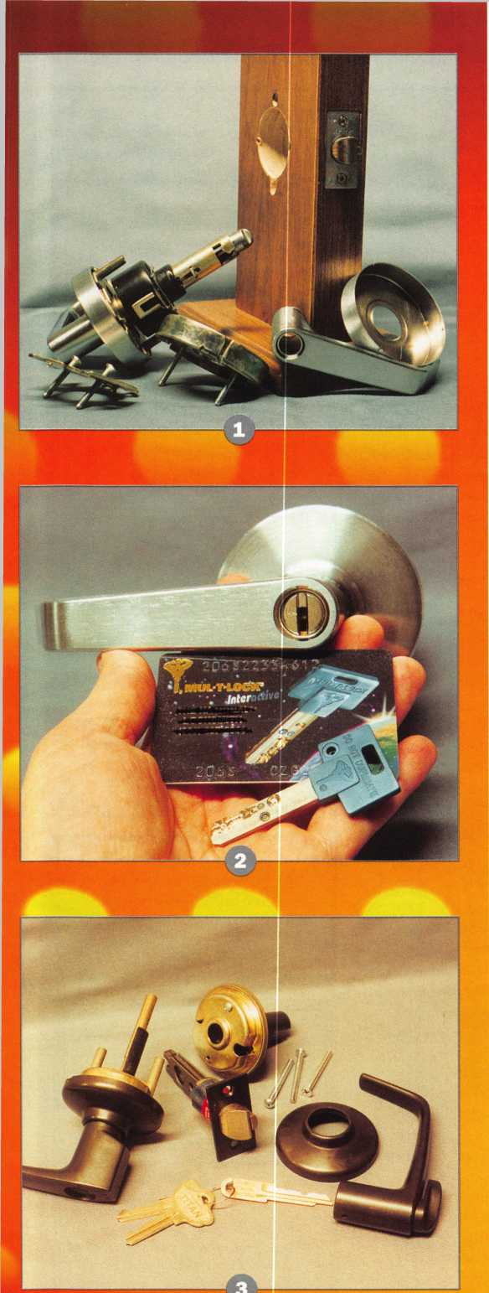

**Commercial Key**

Although lever handles have been found on locks for years, they have only become a commercial standard since the advent of ADA (Americans with Disabilities Act). The lever handle requires less effort and coordination to operate than the more common knob style handle. If the only consideration for designing a lever handle lock was ADA, it would be simple enough for all the different lock manufacturing companies to just make reshaped handles and swap them for existing knob handles.

As most locksmiths and lock companies have learned, making locks more accessible to the disabled created certain side effects.

The lever handle, as opposed to the knob, faces greater vulnerability to both gravity and burglars. As a consequence, you will find that key-in-lever locksets are not just key-in-knob locksets with differently shaped handles. If you look closely, you will realize that the mechanical differences are significant. I will show you a sampling of key-in-lever locksets that will illustrate some of the differences.

# Mul-T-Lock Key-in-Lever

The unique (cut within a cut) Mul-T-Lock key is shown below its key-in-lever lockset, in photo 2. For a Mul-T-Lock key-in-knob lockset, the keyway is normally horizontal (side to side). For most standard key-in-knob locksets that is the exact opposite to the normal vertical (up and down) keyway. Standard key-in-lever locksets require that the keyed cylinder be turned sideways. For the typical lock, the keyway switches from vertical to horizontal. Since the Mul-T-Lock cylinder has a keyway opposited to standard, their normal key-in- knob cylinder starts with an horizontal keyway. The keyway becomes vertical for a key-in-lever lockset.

For servicing or rekeying, you still need to remover the lock handle to get to the cylinder. The key is turned while the knob retainer is depressed in order to release the handle and expose the keyed cylinder for servicing. This type of servicing is typical of most key-in-lever locksets. One major difference between Mul-T-Lock and

# S. Parker 1C Key-in-Lever

Photo 1 shows an S. Parker IC key-in-lever lockset in pieces.

You will find that most key-in-lever locksets have a few more pieces than their equivalent key-in-knob counterparts. If you look at the lock mount you will see two small holes, one each just above and below the 2 1/8 inch diameter cross bore hole. The leverage afforded a disabled person to make the operation of a lock easier, but assists a burglar to apply greater force to the handle without the need for a wrench or similar tool. Through-bolting above and below the lock chassis reinforces the lockset and helps to counteract the leverage of the handle.

The other common problem with lever handles is that they are more visibly affected by gravity. An add-on to the standard handle return spring is a separately encased spring cage, which gives additional force to return the lever handle to a position parallel to the floor. Lever handle locksets so equipped have a lower incidence of sagging levers. Many different lock companies make lever handle locksets that accept Best-style interchangeable cores. The design of the handle requires that the I-Core be sideways.

201 ***Keynotes***

HHI

**l-Lever Locksets**

by Sal Dulcamaro, CML

the others is the reverse position of the keyway (to accommodate  
their keys).

* **Titan Commercial Series Lever**

The Titan commercial series lever is shown in photo 3 and bears  
some general resemblance to the Kwikset/ Titan residential locksets.  
The latch and other parts look similar, except they look significantly  
stronger and more durable. It uses a standard length 6-cut Titan key  
for general operation. It has a special key removable cylinder, that  
requires a special extended length key (with operating key cuts) to  
remove the cylinder for servicing. This contrasts with the standard  
Titan key-in-lever removal key.

Unlike many other commercial key-in-lever locksets, additional  
holes for through-bolting is not necessary. The cylinder removal key  
requires operating key cuts on the extended length key. Once, the  
removal key was inserted and then rotated 180 degrees, then the  
cylinder is ready to come out. The tip of the removal key disengages  
the flat piece so the plug can be rotated 180 degrees. At that point,  
the retainer is in the right spot to allow removal of the cylinder.

* **Marks Survivor Series Lever**

The Marks Survivor series key-in-lever lockset is a heavy  
duty/grade 1 lockset. Photo 4 shows a similar hole mounting pattern  
used for many different brand key-in-lever locksets. The retractor  
piece on the latch tends to protrude a bit further in the lock  
mounting hole (for a grade 1 lockset) compared to a grade 2 lockset.  
The matching part on the chassis, which grabs and pulls in the latch,  
is significantly stronger, along with other parts.

Clutch mechanisms are also significant to resist break-in attempts.  
When the lockset is locked up, the lever handle can be moved but it  
won't retract the latch. The outside handle will only retract the latch  
when the lockset is unlocked, but you can still draw in the latch  
when using the key. Clutch mechanisms remove the apparent  
resistance of the handle to resist force by burglars and their tools.

i **Schlage s e.PRIMUS**

Schlage makes a strictly mechanical grade 1 key-in-lever lockset,  
but built off that same chassis, they have an electronically enhanced  
lockset. The lock called e.PRIMUS is shown in photo 5. Although  
it is key-in-lever, the standard cylinder is the PRIMUS high security  
lock cylinder. The mechanical operation of the PRIMUS lock  
cylinder is designed merely as an emergency mechanical bypass  
to the otherwise electronic lock.

Photo 6 shows it's normal intended operation with an electronic  
(Dallas chip) touch key. The lock can be programmed with special  
electronic programming keys, or with software. Except for the most  
basic model, the e.PRIMUS locksets can be audited to reveal which  
keys operated the lock and at what times.

Although they have certain common characteristics, you will find  
the key-in-lever locksets in a variety of forms, finishes, grades and  
functions. Without the various refinements and reinforcements, they  
would be even easier targets for thieves.

***Keynotes***

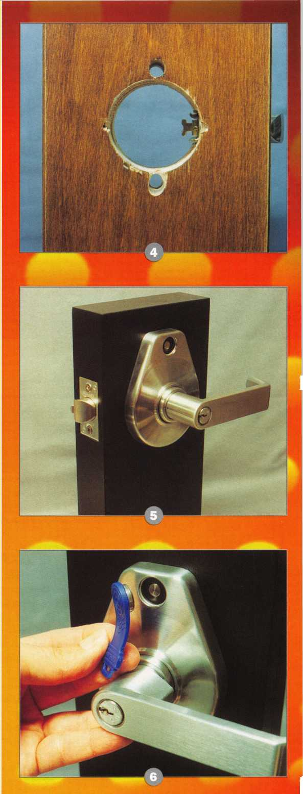

Keynotes

When I was growing up on Chicago’s North Side, my Grandfather (an old world locksmith from Ireland) was busy repairing, adjusting and replacing antique surface mounted rim locks. After a hard day of work as a locksmith, he would stop by my home and show me what treasures he had come across that day. Sometimes, I would go with him to be his helper. little did I realize, the skills and knowledge he passed on to me would benefit not only myself but my family as well.

When I retired to Nantucket, I took up the trade of locksmithing. The first calls for lock repairs were for these ancient and antique surface mounted bit key rim locks.

Surface mounted rim locks have been in existence for well over 2,000 years, in one form or another. The first recorded surface mounted rim locks have been dated around 54 B.C. The Romans began to use surface mounted rim locks throughout their empire. In Britannia (Ancient Britain) in the city of Bath, the Roman Baths are world famous. They are still in existence, although now a major tourist attraction. The doors and locks found during evacuation during the turn of the century verified that ancient surface mounted rim locks were being used to secure the main gates on the estate. On

display in the main exhibition hall, you will see ancient Roman bit keys, made of bronze, used to unlock these surface mounted rim locks. During a recent trip to England, my wife and I visited several major ancient and historical sites. We visited great churches and castles that are still open to the public, and currently in use throughout England, Scotland and Wales. Visiting the interior of Salisbury Cathedral, the first thing that would strike my attention was this huge ancient and antique surface mounted rim lock (pictured at top of page 23), this surface mounted rim lock is located on the interior of the massive Cathedral Doors, which are made of oak and at least 5 inches thick.

They are still in working order and have been in continuous use since the 12th century. Another lock (surface mounted to a side entrance door of the church) is a smaller but similar version of this type of lock. Again, this surface mounted rim lock is attached to a five inch solid oak wood door (note the modern attachment mounted on the upper left hand side of the door, can you guess what it is). It is a bit smaller than the main door lock, however, the design and principle are the same. In this instance, the side door lock is made with wood panels vs. metal sheeting on the main door.

January 2000



by Michael Ferrill

The low profile cylinders that we repair and replace in some Anderson doors today is designed after an English lock currently used today to replace the one to three pound bit key, used since the 12th Century This profile cylinder was designed to fit in these large surface mounted rim locks (and mortise locks), and apply pressure to the levers in these locks.

I’d also like to expand on the rim lock, the role it plays to the locksmith, the importance it played in earlier times, and how it could affect your future. In addition to current product knowledge, available vendors and a new source of income it can bring into your business.

First, let’s talk about going into a older home, town house, tenement building that is being renovated or torn down and removing all old door hardware (to include the hinges). Now, I understand and realize that a number of us collect things. Often times, we run out of available storage space, but you should consider collecting complete quality sets of this type of lock. There are a number of antique hardware companies on the internet that sell antique door hardware. This is because of the cost involved in replacing intricate antique door hardware designs now exceed hundreds of dollars for

just one lock set Remember, old door hardware is no longer available to the general public because the majority of these independent, self started, old world companies that manufactured traditional surface mounted rim locks and mortise ward locks are no longer in business today. We all know that antiques cost money and these types of locks are worth a great deal of money to the particular customer who wants to restore original locks to his historic.

On the island of Nantucket, the architec­tural designers replacing old door knobs and door hardware fixtures will pay a great deal of money for these complete sets, ranging from $55.00 up to $400.00 per set

Ilco currently manufactures a surface mounted, vertical rim lock (part number is 590-04-51) and the cost to the locksmith is around $11.00. It is a very basic lock and comes complete with lock, two keys, spindle, rose and keyhole plate, two brass coated door knobs plus the required screws and strike plate. Remember, this type of lock can be mounted directly to any size door width. On the other end of the spectrum, the Baldwin Hardware Company specializes in this type of lock and sells a number of these types of locksets throughout the world. The

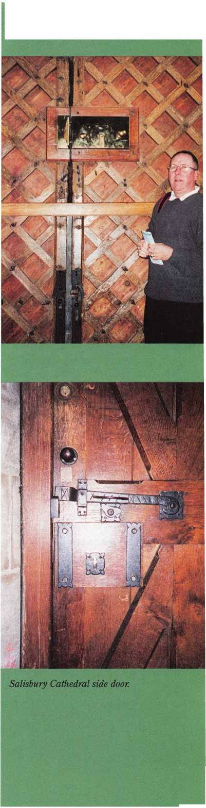

product number is 5600 Series for Vertical Rim Locks, 5700 Series for Horizontal Rime Locks, and 5630-5640 Series Horizontal Rim locks. The cost to the customer can be anywhere from. $479.00 to $875.00. It uses a solid brass rim lock mounted through the outside of the door, interconnected into the rim lock, but also uses a bit key to open and close on the inside of the door.

Now, let’s talk about door knobs and spindles. First, the old fashion door knob (in glass, wood or porcelain) is no longer made in the quantities that were made over 100 years ago. One of the best domestic sources I have found is Ed Donaldson. His mailing address is Edward Donaldson Hardware Restorations, 1488 York Road, Carlisle, PA 17013. He can also be reached by phone at (717) 249-3624. He still maintains, repairs, and refinished these types of locks.

The design of the lock is simple but effective. In most cases, it is made of cast iron This means it is a poured metal into a sand mold as opposed to forged metal, which is stamped after heated to specific temperatures. Being made of cast iron metal, it is subject to breakage due to its brittle nature. This includes the interior parts as well. I have had to replace a number of broken sets due to excessive wear and tear. It consists of two major parts, the outer shell, the cover plate and the back plate. The internal mechanism of the lock set contains springs and various different wards. The skeleton key we comely associate with this type of lock was as intricate as most high security keys today, and still is in some locks

stilled manufactured today by the Lock Companies, Chubb, Lloyds of England and the Jackson Lock Company in Australia.

The lock set is mounted on the door, with screws (minimum three up to six), and will accommodate any type of door thickness (to a degree based upon key thickness and length). It is commonly used on exterior doors and it does present adequate security for that type of door based upon additional length and height (6M X 8"). One inherent design flaw was the length of the latch, which acts as a deadbolt type of locking system. In the majority of these types of lock the usual length of the latch did not extend more then 1/2" to 5/8M. As we know today the average dead bolt latch is 1". A number of companies do make reproductions of these locks, and can be found on the Internet as well.

You will find this type of lock in most American cities and on doors in many countries overseas. There is not one home on Nantucket Island built before 1920 that doesn’t have at least one of these types of surface mounted rim locks on an exterior door. Many of our sea captains returned home, after a long voyage at sea, bringing back to their homes this type of lock.

Today, this lock is still being used on many homes in America, and throughout the world. In fact our brother locksmiths on the British Isles, and on the continent of Australia are just as trained as we are on cylindrical locksets. The companies that make locks have been in existence for just a few hundred years. You should include this

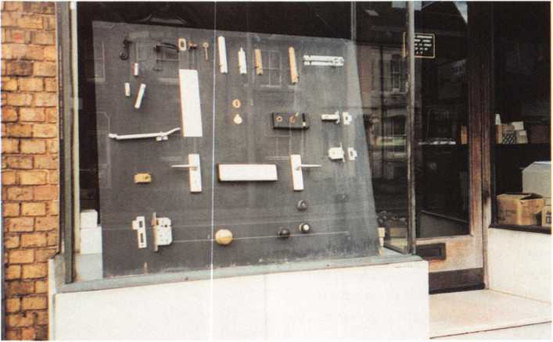

type of lock system in your working knowledge of the craft that you practice today, there are very few islands like Nantucket, but there are still a great number of houses in America today that lend themselves to the seafarers trade of great ships and great captains, that brought back to their home ports these wonderful and ancient locks.

A local shop in Oxford, England still selling surface mounted rim locks.

Keynotes

January 2000

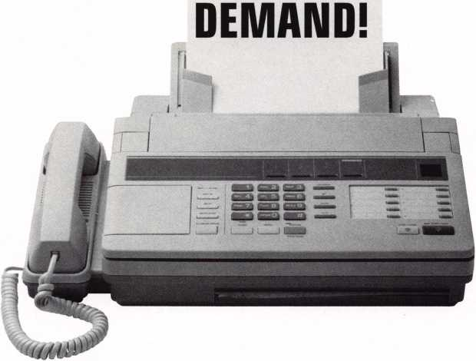

**BE A PART OF 1-800-LOCKSMITH! USE THIS NUMBER IN YOUR CITY & OWN THE MARKET!**

We are looking for qualified locksmiths who want to expand their business and develop themselves into one of the largest locksmith operations in their city. You will be authorized to use our logo and name and we will advertise for you on radio and television.

Interested locksmiths will be able to "secure" as large or as small a territory as they desire. Territories will be based on zip codes.

**Call today for more information or to sign up!**

ALOA  
HAS  
FAX ON

Need information in a hurry?

Just call 310.575.5074 and you will be faxed:

Your association continues to explore  
ways to provide you, our members,  
with new benefits and services.

#1

#2

#3

#4

#5

#6

#7

#8

#9

#10

#11

#12

#13

#14

#15

#16

#17

#18

A list of all documents available through this service

Becoming A Locksmith  
Locksmith Career Summary  
Locksmith School List  
ACE Class Schedule  
Certification Information  
PRP Category List  
ALOA Membership Application  
ALOA List of Benefits  
Scholarship Application Form  
ALOA Video Library Order Form  
ALOA Membership Items Order Form  
Safe & Vault Technicians Association  
Member Application/Subscription Form  
ALOA Chapter Roster  
Legislative Action Network  
Legislative Action Network Newsletters  
Various State Laws  
Industry Position Paper

January 2000

Keynotes

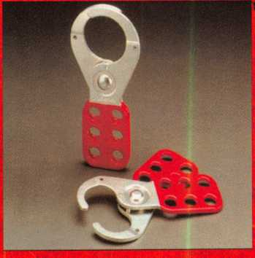

Lock OutAag Out (LO/TO) systems are mandated by OSHA in order to provide life safety for people working on or with heavy machinery, especially for the mechanics who have to keep it running. There has to be a LOAO system in place for any machine that could cause injury if it were turned on while a mechanic is servicing it. For specifics, you can look at OSHA 1910.147. In summary, it says that the energy which makes things work must have the capability for someone to disconnect or disable it, and they need to identify themselves as having done that. "Energy" does not just mean the electrical type; it also includes fluids, gases, thermal, even gravity (like the top half of a 100-ton press)—anything that can cause movement of a machine part. A lock is the accepted means to prevent access to the switches that control energy.

The question that you should be asking is "Where does my customer get those locks?" If you don't know the answer, you should find out if he might

followed. There are times when a workman will  
forget to remove a lock and the lock can be cut off.

Workmen will lose locks and keys, and locks are k  
when employment conditions change. Factories

update old processes and add new equipment which The standard number 3 padlock is

requires obtaining additional locks for lockout. Some available with a couple of options designed

processes (like the reactors that make chemicals)

have as many as 50 lockout points, and one facility

can have several of these processes. All of these

things mean that your customer continually needs  
new locks for his LOAO system, and represent

opportunities for you to get more of his business.

Here are some Master Lock products available for you to offer.

& 421 LOCKOUT HASP

In many cases, there is more than one workman involved when machinery is being serviced. That means there must be a way for more than one person to perform the lockout. The safety

I'm not talking about the little old lady locked out of her home or the harried soccer

wont to get them from you. If so, is he getting the right lock for the job? LOAO system locks have some interesting methods of use and Master Lock has a wide array of products to meet the requirements of those methods.

mom who can't get into her car at the mall. I'm talking about a system for saving lives, a system most of us don't ever really think about: the Lock Out/Tag Out system that is used by almost all of our industrial customers.

421 hasp has all/2

While the best approach is for all of the locks in a clearance. Both are made

given LOAO system to be keyed different, the OSHA „f a heavy gauge steel

rules do allow for other options such as KA and even f0 resjst prying.

MK'd if certain documentation procedures are always

i

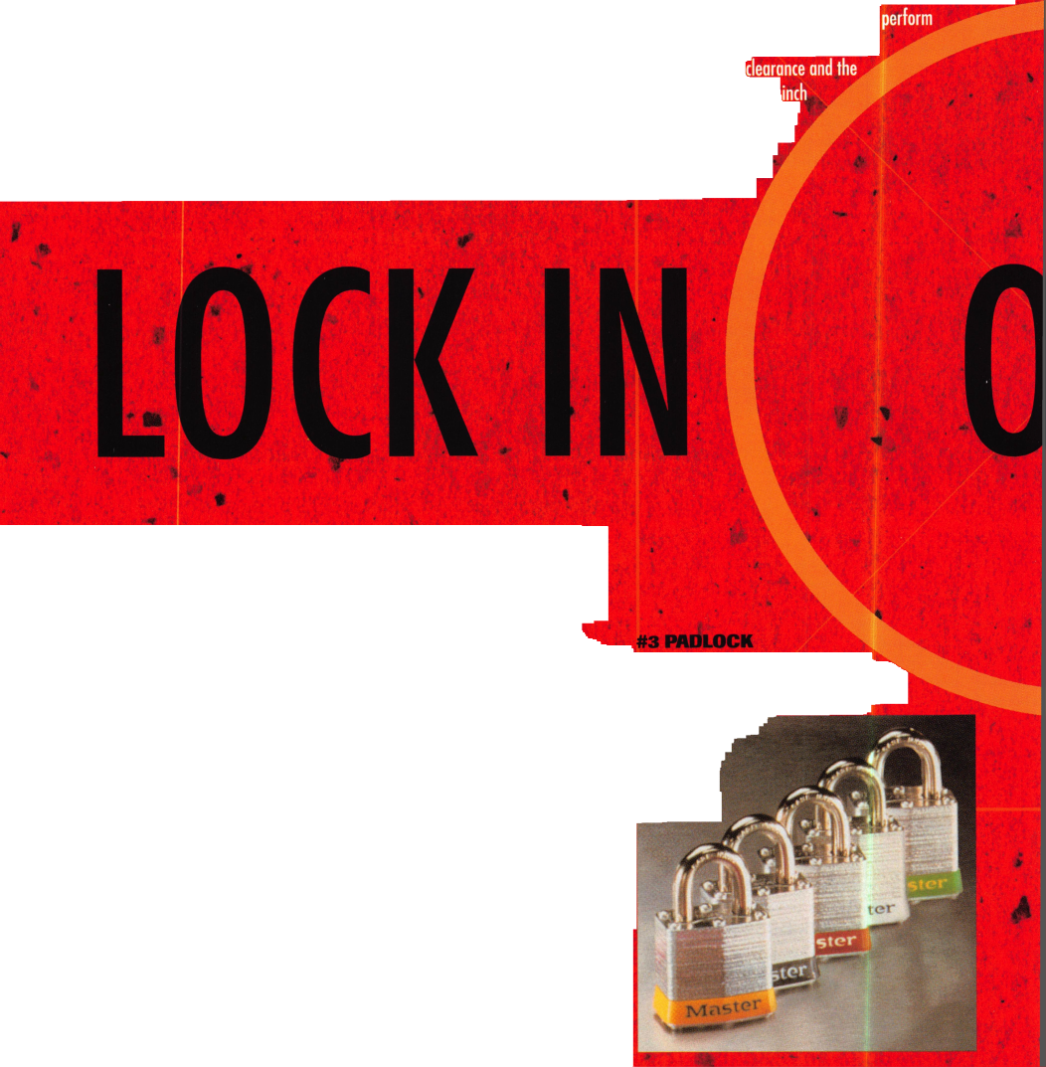

[ g tp taw

***Keynotes*** | 27

These locks were designed especially for the

identification. The ball-bearing locking mechanism resists prying and the six-pin cylinder offers good pick resistance. These locks have keying capabilities of up to 100,000 unique changes. The lock body is sonic welded, and withstands corrosive and rugged industrial environments. Options for these locks include laser engraving on the body, and labels pre­printed with the key number. The 411 lock label is available as either English / Spanish or English / French, and the 410 labels can be requested with Spanish or French.

every year. Approach your customer and see if he will spend his part of that with you. He already trusts you, looks to you as the accepted lock authority, and knows your commitment to service. If you price the locks competitively with the catalog he is using now, you can gain that extra repeat business and recurring revenue. Locksmiths shouldn't be locked out of this market.

If your distributor doesn't have enough product on his shelf to meet your requirement, Master Lock has a 24 hour special delivery program for a limited range of the most popular items. Call your distributor or Master Lock for more details.

The 6835 solid-body aluminum padlock is another good option for use in a LQAO system. Available with six different colors to help in identification, they can also be laser engraved or supplied with a brass ID tag. Because they are ProSeries®, you can rekey them as needed and

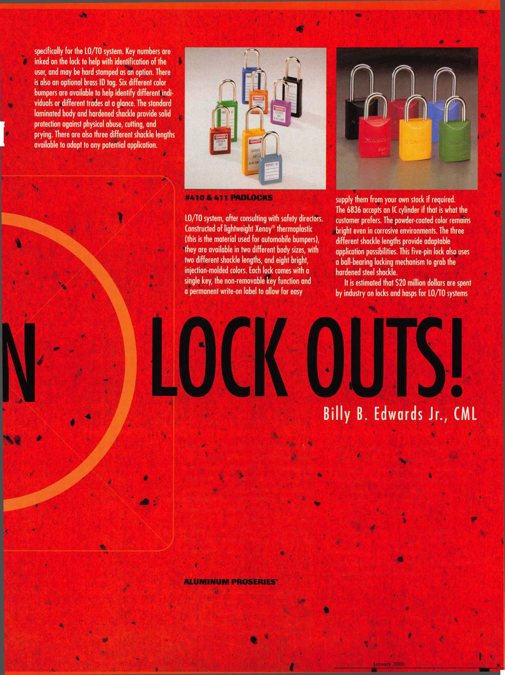

QETTIN' THE LEAD OUT

CALIFORNIA PREMATURELY SUES OVER LEAD CONTENT IN KEYS

**By Tim McMullen**

**On October 12, 1999, California Attorney General Bill Lockyer filed suit against 13 key manufacturers and distributors for allegedly failing to warn that their products expose consumers to the lead found in keys in violation of Proposition 65.**

**Proposition 65—otherwise known as the “California Safe Drinking Water and Toxic Enforcement Act of 1986”— was passed by the voters to protect the public from exposure to toxic substances known to cause cancer or be harmful to reproductive health. California has placed lead on the Proposition 65 list. However, there have been no known instances where a person has been harmed from the amount of lead found in keys.**

**Under the law, businesses are required to provide a “clear and reasonable” warning if there is a daily exposure to more than 0.00000005 grams (.5 micrograms) of lead. This level is extremely low and substantially lower than any other health based level of exposure to lead. Notices may appear in a variety of ways, including warnings on product labels or signs posted where the product is sold. The warning is required unless the business can show that the**



exposure poses no significant risk.

The test to determine the toxicity of the lead content in keys is somewhat suspect. According to the manufac­turers, newly cut key blanks were immediately put into plastic bags and given to participants of the study who had their hands acid-washed. These keys, with residue still on them, were then handled by the study participants. As expected under these circum­stances, lead was found to have rubbed off on their hands.

Unlike most federal and state health and safety regulatory programs, California’s Proposition 65 relies primarily upon litigation rather than interaction with technical experts to achieve compliance. Businesses are expected to provide the data to prove that exposure poses no significant risk. The law provides a fine of up to $2,500 for each violation. The law also provides for a "head-hunter" fee, to be paid out of any fines collected. Section 25191.7(a) of the California Health and Safety Code states, "Any person who provides information which materially contributes to the imposition of a civil penalty or criminal fine against any person for violating this chapter shall be paid a reward... equal to 10 percent of the amount of the civil penalty or criminal fine collected by the department, district attorney or city attorney ” This means that the Eureka environmental attorney who brought this suit in the first place, stands to profit from this lawsuit as well. The law is so out of hand, that pharmaceutical companies are being sued for the lead content in baby powder!

The 13 companies named in the Proposition 65 civil lawsuit filed in the San Francisco Superior Court are: llco Unican Corp., Master Lock Co., Schlage Lock Co., Kwikset Corp., Best Lock Corp., Arrow Lock Manufacturing Co., Weiser Lock Corp., Dexter Co., Jet Hardware Manufacturing Co., Chicago Lock Co., Olympus Lock, Medeco Security Locks and American Lock Co. However, the lawsuit is expected to pull in other manufac­turers and distributors as well.

According to Lockyer, “No one really knows how much of the lead from keys is being ingested, but we do know that consumers are being exposed to lead, some of which may get into the body through hand-to-mouth contact.”

Keys generally are made of brass or nickel silver containing 1.5-2.5% lead,

which makes them easier to cut.

Some high security auto keys are made of unleaded steel, however, most keys contain lead. Chrome-plated keys also produce lower exposure to lead. One manufacturer argues that if they had to change the makeup of their brass key blanks, the cost could go up ten-fold! Plus, with more steel in the key blank, cutting wheels on key machines would have to be replaced more often. The overall cost passed on to the consumer could be significant.

Other than cost, how this lawsuit will affect locksmiths is still somewhat up in the air. ALOA is keeping a close eye on the proceedings, and will become involved if necessary for the security of our members and every locksmith. However, this case could prove to be harmful if the manufacturers are not successful in this lawsuit. Issues in California have a tendency to find their way onto the federal agenda.

Therefore, what happens in the Golden State, may turn out to be not so golden for the rest of the country.

For more information on Proposition 65, check out the web site at <http://www.oehha.org/prop65>.

**TURPI ID**

800-848-9790

One Call  
Gets You...

Amsec

•

Gardall

•

Hayman

Meilink

•

Victor

•

Winchester

Plus Free Delivery  
From America's  
Largest Inventory  
of Safes.

SECURITySS

LOCK COMPANYHP

**New** Factory Replacement Parts and Locks for Security Corporation and Kumahira Safe Co. Products

* Safe Deposit Box Locks and Parts BX, KD
* Automatic Remote Tube Systems (ARTS)
* Drive Up Systems
* Vault Doors
* Night Depositories
* Camera Systems
* Key Blanks and
* Keys Cut to Code

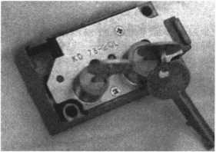

KD Series

Safe Deposit Box Locks

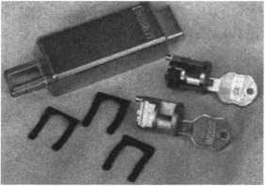

BX Series Safe Deposit Locks

1155 Chess Drive, #114 Foster City, CA 94404 Phone: (650)525-0660 Fax: (650) 525-0444

Email:

[chaslutz@securitylockco.com](mailto:chaslutz@securitylockco.com)



SECURITy

LOCK COMPANY

January 2000 Keynotes

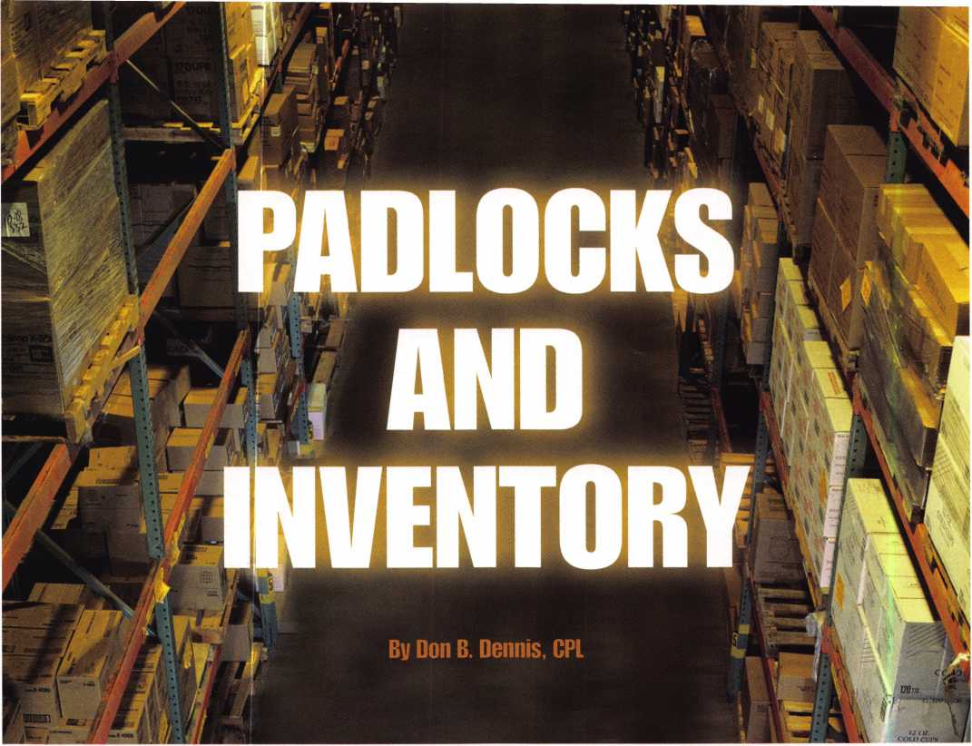

One of the most difficult things to control in the business of locksmithing is the inventory. When have you ever heard the guys and dolls talk about the good old days, when inventory was inventory? I’ve never heard it before and probably never will! As far as the good old days are concerned, inventory was worse then in comparison to today This was particularly true in the area of padlocks.

The evolution has been difficult for the locksmith as well as for the manufacturer. It has driven the distributor mad! You see, not all that long ago, if you wanted a padlock or a door lock that would fit a particular commercial keyway, you had to order that manufacturer’s lock or padlock. Imagine how vast the inventories were! I can remember having 10 Yale entry function knob sets as well as 10 Schlage entry function knob sets. There was the same dilemma in dealing with padlocks. Remembering that there are more functions than just an entry function, there are also more than just one size of padlock that also had to be kept in stock. Indeed, the way we do business has changed drastically.

I believe that the locksmith and the end user

A KeynotesJanuary 2000

have been the winner in all of this.

The manufacturers of major brands are running crazy to keep up with one another while the distributors have to carry the full or a partial line of each manufacturer as well as the new bullies on the block that we locksmiths call the generics.

What does all of this insanity mean?

I believe that what we are witnessing is capitalism at its best. We are seeing the generic products coming in from all over the world and the locksmith, home building retailer, and hardware stores are using the products. Somewhere in the future the archi­tectural people will also begin the generic approach. We are seeing the manufacturers of the major brands, while still manufacturing their standard lock products, expanding into electronics and high security. They are also addressing their efforts to the low end product line such as Schlage did with their “F” series. It appears that this approach is a natural evolution.

Let’s look at the padlock and how the changes are helping the locksmith. Again, instead of having many different lines of padlocks to agree with the different

manufacturers, we are settling into one to three choices. For my situation, my customer base seems to want Master, American or Abus. You will find that as you travel to different regions of the world there is a different choice of what needs to be in stock. We are seeing Master, American and Abus all producing locks that will conform to the keyways of the major manufacturers. If they do not produce the cylinders, then they are producing the lock that will accept the original as well as the generic. All of this new found compactness in inventory has saved us a great deal.

Until recently, we saw changes in padlocks occurring only in the construction and in the materials. There have been changes in the steel dealing with Rockwell hardness. There have been aluminum bodies and boron alloy shackles. Now, we find shrouds covering the majority of the shackle with weatherproofing from thermoplastic covers and rubber gaskets. The keys have progressed from the old styles of warded padlocks to lever tumblers and finally arriving at the pin tumbler. In the area of the pin tumbler evolution, manufacturers began

to make several different key ways. These keyways became field changeable and finally has evolved to the use of commercial keyways.

It’s in these commercial keyways that a distinctive mark is being made on the locksmith’s pocketbook. First of all, we have to carry fewer inventory items. Second, it’s more profitable. It seems that almost every day a customer asks for a padlock. As I query them, I find that they are willing to pay a little more to have the convenience of not having to carry another key in the applica­tion of the new security. There are still those who just want a padlock and I’ll sell them what they want. For those who want to make the move to padlocks with keys that will fit their home, the profits take a major increase. The locksmith has the opportunity to sell the padlock, rekey the padlock, and when the customer needs to rekey their home the padlock combination change will be part of it. This padlock may also need to be master keyed. If the padlock is going on a yard gate, it needs to fit the customer’s house key with another key for the person maintaining the yard. Another sales point is if the children of the household are doing the yard work then it may be time to teach the kids to be responsible in keeping up with keys. Instead of giving the kids a house key to lose, they get just the gate key. You have just increased your sales by the cost of the master keying as well as additional keys.

It’s just good business to make your commercial customers aware of the options of using padlocks that fit their business property keys! The majority of them, with padlock applications, will not think long before accepting your suggestion. I recall an event that occurred 10 years ago. I arrived to change the combination on the front door of a service-orientated business. They had just fired a manager and several of the drivers of their fleet. All of the trucks used padlocks as well as their gate. I came to find out that they had a maintenance individual who kept several tool and part bins that also required padlocks. That job went from about $65.00 to well over $3000.00.1 sold them the front door combination changes with keys and more than 80 padlocks in sets of 4 with keys. When I mentioned to the boss of the outfit that he may want to master key all of this for his convenience, he couldn’t wait! By the end of the next day he signed the check with a smile on his face and I had a new and fruitful

business relationship. A relationship that has gone on for all of these years with him firing managers and service vehicle drivers. He still signs the check with a smile and a good handshake. I should mention that what was done for his business was also applied to his home. The money just keeps coming in! It all happened because I took the time to sell a padlock.

This incident has repeated itself several times over the years with varying degrees of success. While I do not keep 80 padlocks on the shelf, I do keep between 15 to 25 that have the capability of having cylinders that will fit my customers needs. Remember the 10 knob locks that I mentioned earlier? I find that my inventory and customer base requires me to maintain 15 knob locks of entry function, five of classroom function, and about two of storeroom function. These quantities are further broken down into different finishes that would suit my commercial customer base. That is a total of approximately 42 locks when you combine padlocks and knob locks. (This has changed a bit since levers have come onto the scene.) The inventory in the “good old days” would have been at least tripled! As for the keyway cylinders in stock, I would keep about 10 cylinders on each of the keyways that dealt with my customer base. This would be 10 of each of the following cylinders (Lori or comparable): Yl, SCI, SCK, 6D1,981, KW1, and WR3. These cylinders would then fit both the padlocks and knob locks. Should an occasion arise where I needed something else I could make a “next day air” order to fill the need. It’s important to keep your money in your pocket and not tied up in your inventory. The evolution of the padlock has made the task of inventory control much easier and much more manageable.

I have mentioned throughout this article about my customer base. My automotive work, residential work and walk-in customers are considered as incidentals. The only reason that they are not considered in the inventory is because they are here one day and gone the next. It’s not that I do not carry deadbolts and other items. I do. These are treated just as the knob lock/padlock cylinders. Generally, I use (Lori or comparable) mortise cylinders with some product like a Lori deadbolt. This allows me to use the mortise cylinders in deadbolts as well as in aluminum glass doors. Should your

customer base include an automotive dealer or used car dealer then you would have to take a different approach. My customer base is founded in the commercial sector. Whatever your customer base may be, it’s the customer base that will decide on the inventory that you must keep. Do not try and keep an inventory of everything that is made! I know this sounds crazy but I have seen shops that try and keep every lock that is made by a particular manufacturer. That lock may stay on the shelf for three years before it’s sold or discarded.

You want your inventory to completely turn over at least twice a year. If you cannot sell a product more than twice each year, it’s not profitable to keep it on the shelf! You are losing money! You are paying taxes on that product just sitting there! Don’t do it! It’s comforting to say that I stock a full line of whatever. This would be a wasted and false boast. It’s more comforting to know that you are making money using sound business decisions!

With our current situation with distribu­tors, it’s easy to place a “next day air” or a “two day air” request in order to satisfy a customer’s needs. Yes, you will loose a little of your profit in freight (maybe) but not as much as if you had the item in stock and did not sell it. I will be happy to say, “I am out of stock” and even call it bad planning so long as my pocket book will not be the victim! I can remember loosing a sale where I did not have the item in stock. I also know that for more than 12 years now I have not had another request! In the long run I am the winner.

You will find that business is constantly changing and even with a few bad decisions you will more than likely come out on the good side of things. Locksmiths are great at finding enough money to get from one month to the next. They are not generally speaking, great business people since there are few of us that take the time to learn our lessons before we need to apply them. Take enough time as you go through your lock- smithing career to learn about business. You learn about how to open a car or how to use a new tool. By learning about business you will have the money to buy the next gimmick and still save for old age!

January 2000

***Keynotes*** li!

Legislative Update

by Tim McMullen

ALOA WORKING HARD FOR MEMBERS IN OHIO

On October 23, 1999 ALOA, its North Coast Chapter, Ohio Valley Chapter and the Pennsylvania-Ohio Locksmith Association met with the Ohio Burglar and Fire Alarm Association (OBFAA) on alarm licensing legislation that is currently moving forward in their state. The Ohio law will license business owners and their employees who sell, install or repair “electronic security systems.” As defined in the bill, these systems include burglar or intrusion detection, fire detection, access control and closed circuit television. Access control is defined as “any combination of equipment and devices designed and arranged for the control of individuals, vehicles, and materials through entrances and exits of a controlled area or premises.” To qualify for a license, you must take NTS Levels 1 and 2. As you can see, this has far reaching effects for locksmiths, reminiscent of Texas.

However, exempted from the licensing law are, “Locksmiths not providing direct sales, monitoring, installation, or service of Electronic Security Systems to Electronic Security System Users, but who may provide single point alarm functions at an entrance or exit that are not part of Electronic Security System provided by them.”

At this meeting, ALOA stressed, and OBFAA recognized that locksmiths, not alarm people should be defining our profession, and offered to amend their law with a definition that we develop. Our proposal is to define the profession in such a way, that it will also exclude access control and CCTV, and that licensing be limited to those electronic security systems that require an emergency response from police and fire personnel or are tied into systems that restrict emergency egress.

However, OBFAA’s two concerns are that only licensed individuals be allowed to install fire alarm systems, and that people will not try to get around the law by calling themselves a locksmith. Robert Turner (who as luck would have it, is an ALOA/POLA member and sits on the OBFAA Board), assured everyone that it was not OBFAA's intention to put locksmiths out of business or to regulate self- contained facilities. Everyone was in agreement, that any system that was tied to a fire safety system should fall under this law for liability reasons.

Two of the provisions in the bill that are of some interest are that there is no grandfathering clause (Ohio will not allow it) and that there will be no Board, because oversight of the licensing will be done through a current governmental department. The bill also does not address the issue of single-employee businesses, which Tom said OBFAA will need work on.

The Ohio Legislative Service Commission (LSC) is currently reviewing the bill. After they have a chance to review it and make sure it is drafted properly, then it will be introduced. There still may be a chance these changes are not made, and the North Coast Chapter, the Ohio Valley Chapter and POLA will have to come together and hire a lobbyist to protect our interests in Ohio (see below).

ALOA is committed to ensuring that another situation like Texas or Alabama does not happen again, and that locksmiths will still be able to do access control and CCTV without having to get an alarm license.

YES! I support ALOA in its fight against legislation that is bad for locksmithing—bad for my business!

Enclosed is my donation in the amount of: l I $100 L J $75 !—J $50 l—] $35 C—J $25 !—J Over $100 _

Indicate type of funds: L J MasterCard [J Visa i i American Express I I Check L Money Order

Credit Card Number: Expiration Date: /

Name (as it appears on card):

Signature:

L .1 Please use my donation for the state of OHIO exclusively.

Federal law mandates that political donations are not tax deductible.

Please make checks payable to “ALOA LEGISLATIVE FUND.”

IS! Mail this completed form with your donation to:

ALOA LEGISLATIVE FUND, 3003 Live Oak Street, Dallas, TX 75204.

32

Keynotes

January 2000

A L O A

Policy

There are two methods available for a member to be reinstated after a lapse in their membership, and allow the retention of their original member number:

1. Full payment of all past and current dues will allow their “member since” year status to continue to be shown as the year in which they initially joined the association and they will be afforded all benefits that are currently available.

2. Full payment of an Administrative Fee, (currently $40.00) as well as all current dues will change their “member since” to the year in which they were reinstated.

ORDERS MADE  
TORT.

At Stone & Berg, we pride ourselves in having more than 5,500 different llco Unican key blanks in stock at one time. So we’re ready when you need us most. Whether you have a call for a hard-to-find key blank or one of the popular llco Unican key numbers,

Stone & Berg is ready to fill the order. And we are constantly updating our llco key blank invent­ory. That's how we stay ahead of the competition.

And that's how we’ll help you stay ahead of yours. So call us when you need it, and it will be there.

That’s the 30 years of Stone &

Berg tradition you’ve

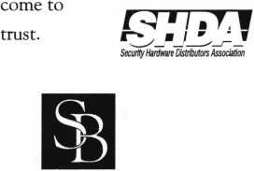

Stone & Berg

Wholesale Locksmith Supply Company

(800) 225-7405 • Fax: (800) 535-5625

January 2000

Keynotes



Keynotes

Classified



**Classified Advertising Policy**

**Classified advertising space is provided free of charge to ALOA members, and for a  
fee of $.60 per word, $15 minimum for non-members. Classified ads may be used to  
advertise used merchandise and overstocked items for sale, “wanted to buy” items,  
business opportunities, employment opportunities/positions wanted and the like.  
Members or non-members wishing to advertise services or new merchandise for  
sale may purchase a “Commercial Classified Ad,” for a fee of $1.30 per word, with a  
minimum of $40. Each ad will run for two issues. For blind boxes there js a $5 charge  
to members and non-members. All ads must be submitted in writing to the ALOA  
office by the fifteenth of the month, two months prior to issue date. Send to  
Keynotes Classifieds, 3003 Live Oak SL, Dallas TX 75204-6186. ALOA reserves the  
right to refuse any classified advertisement that it deems inappropriate**

**according to the stated purpose of the classified advertising section.**

■ EMPLOYMENT Automotive Locksmith Wanted

12/F/3: Relocate to South Florida and throw away your deadbolts and 3 keys for a dollar. We run over 300 calls per week. You must own a truck with tools and code equipment to cut all foreign and domestic keys. You can earn $800 to $1500 per week. Please, if no truck or tools-no calls.

South Florida Lock & Safe (800) 928-2926

Commercial Locksmith Wanted

12/F/3: One of Atlanta’s largest and most prestigious commercial mechanical security companies is seeking an experienced, highly motivated self-starting technician who is capable of handling and carrying himself well and the ability to service clients in a corporate environment. Relocation compen­sation and signing bonus is an option for the right individual. Send resume to:

Rhonda Cheek, VP Operations

All State Access Lock and Security Company

2274 Atlanta Road

Smyrna, GA 30080

(770) 434-9966

Experienced Service &

Shop Technicians Needed

12/F/3: Due to continued growth, we are looking for outside and inside service technicians. Our company has been in business since 1880 and is located in the beautiful Pacific Northwest. Argens Incorporated is a multi dimensional company. We target commercial and industrial accounts of all sizes. Our company specializes in general locksmithing, electronic security (card access & CCTV), door servicing and gate systems. We are an employee driven company with excellent pay, benefits, sale incentives and can offer advancement as our growth continues. Send resume to:

Jim King Argens Incorporated 84 S Main Street Seattle, WA 98104 (206) 623-2662 (206) 622-3036 fax argens@w-link. net

Experienced Technician Wanted

12/F/3: Family owned business since 1911, serving Knoxville and surrounding areas in East Tennessee are in need of experienced commercial, industrial and residential technicians. Must supply background check, work and personal references, have a clean driving record, no felonies, able to work as a team player, neat, honest and good communication skills. Salary with monthly and yearly bonuses. Insurance and retirement plan after 90 day trial, paid vacation and sick days after one year. Send resume and cover letter to:

Attn: William M. Peters Jr., CRL F. M. George Safe & Lock Co., Inc.

P0 Box 3398

Knoxville, TN37927-3398

Service Tech Wanted

12/3/F: Established locksmith company is seeking service technician with commercial experience. Must be professional and ambitious. Qualified technician can earn up to $18 per hour. Medical insurance, vacation, plus other benefits. Submit resume.

(362) 464-0333 (362) 464-0333 fax

Experienced Technician Wanted

12/F/3: Join a fast growing 23 year old firm in America’s #1 place to live, Nashua, New Hampshire. Top wages in area paid to career oriented professional with excellent benefit package.

New Hampshire Safe and Lock 343 Amherst Street Nashua, NH 03063 (800) 838-0132 (603) 889-2849fax nhsafelock@aol. com

Locksmith

ll/F/3: Company doing services for financial institutions has a great opportunity for a general-purpose locksmith to service the Seattle area. Must have vault and safe experience. Competitive salary, benefits and company vehicle provided. Clean driving record required. Fax resume to:

Attn. Grant Driskill (303) 670-0743

* BUSINESSES FOR SALE Business For Sale

12/P/3: Established locksmith business for sale in western Missouri. Recently assessed at 160K. Still growing. Industrial, institu­tional accounts as well as automotive, residential, bank and commercial accounts. Access control experience a plus. Master keying knowledge a must. Safe and safe deposit box service and repair experience helpful. Equipped van negotiable. Good location in growing community. Asking 160K. Owners seeking change. Only serious inquiries please. Reply to:

Keynotes Classifieds 3003 Live Oak Street Dallas, TX 73204 (214)827-1701

* WANTED TO BUY/SELL Wanted To Buy

ll/F/3: Wanted used 1200 HPC Machine Call: (301) 627-3876

Wanted To Buy/Sale

12/F/3: Old key blanks, Hurd, Briggs- Stratton, Yale, etc. I will pay $1 each. Send me a list of what you have.

Douglas Vogel

4779 Meadow Lark Lane

Dexter, Ml 48130

For Sale

12/F/3: 30 used Corbin ML2267 knob mortise locks. Abloy equipment, Key machine, deadbolts, cylinders and keys. Make offer.

A-l Lock & Key (303) 339-9999.

Keynotes

January 2000

**January 2000**

United States Postal Service

Statement of Ownership, Management, and Circulation

|  |  |  |
| --- | --- | --- |
| 1. Publication Title.  KEYNOTES | 2. Publication Number | 3. Filing Date  10/08/99 |
| 02 77-079 2 |
| 4. Issue Frequency  Monthly except July/Aug issue | 5. Number of Issues Published Annually  11 | 6. Annual Subscription Price  Member benefit |
| 7. Complete Mailing Address of Known Office of Publication (Notprinter) (Street, city, county, state, andZiP+4)  3003 Live Oak St. Dallas, TX 75204-6186 | | Contact Person  Mike Emerv |
| Telephone  (214) 827-1701 |

8. Complete Mailing Address of Headquarters or General Business Office of Publisher (Notprinter)

Associated Locksmiths of America Inc. (ALOA)

3003 Live Oak St. Dallas, TX 75204-6186

9. Full Names and Complete Mailing Addresses of Publisher, Editor, and Managing Editor (Do not leave blank) Publisher (Name and complete mailing address)

Associated Locksmiths of America Inc. 3003 Live Oak St. Dallas, TX 75204-6186 Editor (Name and complete mailing address)

Mike Emery

Associated Locksmiths of America Inc. 3003 Live Oak St. Dallas, TX 75204-6186 Managing Editor (Name and complete mailing address)

10. Owner (Do not leave blank. It the publication is owned by a corporation, give the name and address of the corporation immediately followed by the names and addresses of all stockholders owning or holding 1 percent or more of the total amount of stock. If not owned by a corporation, give the names and addresses of the individual owners. If owned by a partnership or other unincorporated firm, give its name and address as well as those of each individual owner. U the publication is published by a nonprofit organization, give its name and address.)

|  |  |
| --- | --- |
| Full Name | Complete Mailing Address |
| Associated Locksmiths of America Inc. | 3003 Live Oak Street Dellas. TX 75204-6186 |
|  |  |

|  |  |
| --- | --- |
| 11. Known Bonanoloers, Mortgagees, and Other Security Holders Owning or Holding i Percent or More of Total Amount of Bonds, Mortgages, or  nth**' Q/ar;mtioc If nnnn rhprlr hrw |  |
| ^ V- | |
| Full Name | I Complete Mailing Address |

12. Tax Status (For completion by nonprofit organizations authorized to mail at nonprofit rates) (Check one)

The purpose, function, and nonprofit status of this organization and the exempt status for federal income tax purposes: (3 Has Not Changed During Preceding 12 Months

□ Has Changed During Preceding 12 Months (Publisher must submit explanation of change with this statement)



F

|  |  |  |  |  |
| --- | --- | --- | --- | --- |
| 13. Publication Title  KEYNOTES | | | 14. Issue Date for Circulation Data Below  NOVEMBER 1999 | |
| 15. |  | Extent and Nature of Circulation | Average No. Copies Each Issue During Preceding 12 Months | No. Copies of Single Issue Published Nearest to Filing Date |
| a. Total Number of Copies (Netpress run) | | | 9875 | 8500 |
|  | (D | Paid/Requested Outside-County Mail Subscriptions Stated on Form 3541. (Include advertiser's proof and exchange copies) | 7691 | 7691 |
| b. Paid and/or | (2) | Paid In-County Subscriptions (Include advertiser's proof and exchange copies) | 86 | 86 |
| Circulation | (3) | Sales Through Dealers and Carriers, Street Vendors, Counter Sales, and Other Non-USPS Paid Distribution | 0 | 0 |
|  | (4) | Other Classes Mailed Through the US PS | 0 | 0 |
| c- Total Paid and/or Requested Circulation (Sum of 15b. (1), (2),(3),and ^ (4)1 r | | | 7777 | 7777 |
| dFree  Distribution | (1) | .Outside-County as Stated on Form 3541 |  |  |
| by Mail  (Samples,  compliment | (2) | In-County as Stated on Form 3541 |  |  |
| ary, and other free) | (3) | Other Classes Mailed Through the USPS |  |  |
| e.  Free Distribution Outside the Mail (Carriers or other means) | | | 250 | 250 |
| f. .  Total Free Distribution (Sum of 15d. and 15e.) p | | | 250 | 250 |
| g. .  Total Distribution (Sum of 15c. and 15f) \ | | | 8027 | 8027 |
| h.  Copies not Distributed | | | 1848 | 473 |
| Total (Sum of 15g. andh.) ^ | | | 9875 | 8500 |
| i- Percent Paid and/or Requested Circulation (15c. divided by 15g. times 100) | | | 97% | 97% |

D. ruoiicaiion oi oiaiemem oi uwnersmp

Cfc Publication required. Will be prjpted in the JANUARY 2000 issue of thj$ pupation

□ Publication not required.

I certify that all inlprmauon^urnished on this form is true and complete. I understand that anyone who furnishes false or misleading information on this form or who omits nratfcrialgrjnformation requested on the form may be subject to criminal sanctions (including fines and imprisonment) and/or civil sanctions (including civil (Wnalties).

Instructions to Publishers

1. Complete and file one copy of this form with your postmaster annually on or before October 1. Keep a copy of the completed form for your records.
2. In cases where the stockholder or security holder is a trustee, include in items 10 and 11 the name of the person or corporation for whom the trustee is acting. Also include the names and addresses of individuals who are stockholders who own or hold i percent or more of the total amount of bonds, mortgages, or other securities of the publishing corporation. In item 11, if none, check the box. Use blank sheets if more space is required.
3. Be sure to furnish all circulation information called for in item 15. Free circulation must be shown in items 15d, e, and f.
4. Item 15h., Copies not Distributed, must include (1) newsstand copies originally stated on Form 3541, and returned to the publisher, (2) estimated returns from news agents, and (3), copies for office use, leftovers, spoiled, and all other copies not distributed.
5. If the publication had Periodicals authorization as a general or requester publication, this Statement of Ownership, Management, and Circulation must be published; it must be printed in any issue in October or, if the publication is not published during October, the first issue printed after October.
6. In item 16, indicate the date of the issue in which this Statement of Ownership will be published.
7. Item 17 must be signed.

Failure to file or publish a statement of ownership may lead to suspension of Periodocals authorization.

PS Form 3526, September 1998 (Reverse)

Associate

Members



|  |  |
| --- | --- |
| Manufacturers | Arrow Lock Company  10300 Foster Avenue  Brooklyn, NY 11236 (718) 257-4700; FAX (718) 649-9097 |
|  | a a a a |
| A & B Safe Corp.  171 S. Delsea Dr.  Glassboro, NJ 08028 (800) 253-1267; FAX (609) 863-1208 | Auto Security Products (A. S. P.)  P.0. Box 10  Redmond, WA 98073-0010 (425) 556-1900; FAX (425) 558-1205 |
| • • • • | a a |
| ASSA Inc.  10300 Foster Ave.  Brooklyn, NY 11236 (800) 235-7482; FAX (718) 257-2772 | BWD Automotive  900 Ravenwood Dr.  Selma, AL 36701  (334) 874-9001; FAX (334) 874-6011 |
| e | a a |
| Abus Lock Company  3555 Holly Lane North  Plymouth, MN 55447-0507 (800) 352-2287; FAX (612) 509-9939 | Chicago Lock Company  10100 88th Ave.  Pleasant Prairie, Wl 53158-0069 (800) 445-3204; FAX (414) 947-7178 |
| • | a |
| Adams Rite Manufacturing Co.  P.0. Box 1301  LaPuente.CA 91749-1301 (562)699-0511; FAX (562) 699-5094 | Corbin Russwin Architectural Hardware  P.0. Box 25288  Charlotte, NC 28229 (800) 543-3658; FAX (800) 447-6714 |
| ease | a a a a |
| Adesco Safe Manufacturing Co.  web; [www.adesco.com](http://www.adesco.com) email: [sales@adesco.com](mailto:sales@adesco.com) (800) 821-6803; FAX (562) 408-6427 | Curtis Industries  6140 Parkland Blvd, Ste. 300  Mayfield Heights, OH 44124-4103 (800) 555-5397 |
| • | a a |
| Adrian Steel Company  web: [www.adriansteel.com](http://www.adriansteel.com)  Adrian, Ml 49221  (800) 677-2726; FAX (517) 265-5834 | DETEX  302 Detex Dr.  New Braunfels, TX 78130 (800) 729-3839; FAX (830) 620-6711 |
| e | a a a a |
| Alarm Lock Systems, Inc.  345 Bayview Ave.  Amityville, NY 11701 (800) ALA-LOCK; (516) 789-3383 | Don-Jo Manufacturing, Inc.  P.0. Box 929  Sterling, MA 01564 (508)422-3377; FAX (508) 422-3467 |
| • | a a |
| Aiphone Intercom Systems  1700-130th Avenue, NE  Bellevue, WA 98005 (425) 455-0510; FAX (425) 455-0071 | Door Controls International  2362 Bishop Circle East  Dexter, Ml 48130  (800)742-3634; FAX (800) 742-0410 |
| • • • | a a a a |
| American Lock Co.  3400 West Exchange Road  Crete, IL 60417-2099 (708) 534-2000; FAX (708) 534-0531 | ESP Lock Products, Inc.  375 Harvard Street  Leominster, MA01453 (978) 537-6121; FAX (978) 534-9109 |
| a a | a a |
| American Security Products (AMSEC)  11925 Pacific Ave.  Fontana, CA 92337-6963 (800) 423-1881; FAX (909)685-9685 | Folger Adam Security, Inc.  16300 W. 103rd Street  Lemont, IL 60439  (630) 739-3900; FAX (630) 739-6138 |
| a a | a a |
|  |  |

Associate members of the Associated Locksmiths of America (ALOA) manufacture or distribute materials or equipment, or provide services, for the security industry. Many have donated money, services and equipment to ALOA in addidon to their annual dues. Their support of ALOA projects enhances overall membership benefits and we encourage our members to patronize these firms. If you know of a potential candidate for associate membership, please contact the ALOA Membership staff at (800) 532-ALOA. Associate member dues are $500 per year and entitle the payor to use the ALOA logo, and receive selected discounts on ALOA products and services.

Legend

Personal, vehicle, electronic, fire, burglar, and exit

® Automotive: Lockout equipment, key chains/rings

9 Builders Hardware: Door closers, furniture/decorative hardware, viewers, emergency exit devices

Books, reference guides, publications, computer software

9 CCTV/Photo Imaging: Cameras, monitors, photo ID equipment, cables

access control and readers, surveil­lance, electric/magnetic locks and strikes, keypads

9 Lock Devices: Auto locks, cylinders, emergency exit/entrance control, locks (various types), strikes

9 Tools & Supplies: Key blanks, cutters, picks, rings/hooks, custom van/truck supplies



36

***Keynotes***

January 2000

|  |  |  |
| --- | --- | --- |
| Fort Lock Corp.  3000 N. River Rd.  River Grove, IL 60171 (708) 456-1100; FAX (708) 456-9476 | LCN Closers (Division of Ingersol)  121 W. Railroad Ave.  Princeton, IL 61356 (815) 875-3311; FAX (815) 875-3222 | STRATTEC Security Corp.  3333 W. Good Hope Rd.  Milwaukee, Wl 53209 (414) 247-3333; FAX (414) 247-3329 |
| ® ® ® ® | • | • • • |
| Grobet File Co. of America  750 Washington Ave.  Carlstadt, NJ 07072 (800) 962-7242; FAX (800) 243-2432 | La Gard, Inc.  3330 Kashiwa Street  Torrance, CA 90505 (310) 325-5670; FAX (310) 325-5615 | Sargent & Greenleaf, Inc.  P.O. Box 930  Nicholasville, KY 40340-0930 (606) 885-9411; FAX (606) 887-2057 |
| • | 9 9 9 | • • • • |
| H.E.S., Inc.  2040 W. Quail Ave.  Phoenix, AZ 85027 (602) 582-4626; FAX (602) 582-4641 | Lucky Line Products  7890 Dunbrook Rd.  San Diego, CA 92126 (619) 549-6699; FAX (619) 549-0949 | Schlage Lock Co.  1915 Jamboree Suite 165  Colorado Springs, CO 80920 (800) 847-1864; FAX (800) 452-0663 |
| • • • | • | • • |
| HPC, Inc.  3999 N. 25th Avenue  Schiller Park, IL 60176 (847) 671-6280; FAX (847) 671-6343 | M.A.G. Engineering & Mfg. Inc.  15261 Transistor Lane  Huntington Beach, CA 92649 (714) 891-5100; FAX (714) 892-6845 | Schwab Corporation  110 Professional Court  Lafayette, IN 47905 (765) 447-9470; FAX (765) 447-8278 |
| • • • | • • • | • |
| HID Corporation  9292 Jeronimo Road  Irvine, CA 92618  (949) 568-1600; FAX (949) 568-1680 | MARKS USA  5300 New Horizons Blvd.  Amityville, NY 11701 (516) 225-5400; FAX (516) 225-6136 | Securitron Magnalock Corp.  550 Vista Blvd.  Sparks, NV 89434  (800) 624-5625; FAX (702) 355-5636 |
| 9 # | • | • • |
| Hongtai Lock Co. Ltd.  Jidong, Xiaolan Road, Xiolan Zhongshan/Guangdong, China 528415 (86) 137-238-1414; FAX (86) 208-793-3856 | MUL-T-LOCK USA, Inc.  300-1 Route 17 South Suite A  Lodi, NJ 07644  (800) 562-3511; FAX (973) 778-4007 | Security Door Controls  3580 Willow Lane  Westlake Village, CA 91361 (805) 494-0622; FAX (800) 959-4732 |
| • • • • | 9 9 9 | 9 |
| llco Unican  400 Jeffreys Road  Rocky Mount NC 27804 (252) 446-3321; FAX (252) 446-4702 | Master Lock Company  2600 North 32nd Street  Milwaukee, Wl 53211 (414) 444-2800; FAX (414) 449-3114 | Security Solutions  1640 W. Hwy. 152  Mustang, OK 73064 (405) 376-1600; FAX (405) 376-6870 |
| ••••••• | • • | 9 9 9 |
| In Out Systems, Inc.  3650-B Matte Boulevard  Brassard, Quebec J4Y-2Z2, Canada (450) 444-5949; FAX (450) 444-4856 | Medeco Security Locks  P.O. Box 3075  Salem, VA 24153  (540)380-5000; FAX (540) 380-5010 | Sentry Group  900 Linden Ave.  Rochester, NY 14625-2784 (716) 381-4900; FAX (716) 381-8559 |
| fl> • | • • • | • |
| Intellikey  551 S. Apolo Boulevard, Suite 204  Melbourne, Florida 32901 (800) 226-0703; FAX (407) 724-0811 | Meilink Safe Company  111 Security Parkway  New Albany, IN 47150 (800) 634-5465; FAX (800) 896-6606 | Sully Tools Inc.  3515 Nodding Pine Ct.  Fairfax, VA 22033  (703) 689-3416; FAX (703) 787-0869 |
|  | • | 9 9 9 |
| KABA High Security Locks  P.O. Box 490  Southington, CT 06489 (860) 621-3601; FAX (860) 621-9727 | National Cabinet Lock  200 Old Mill Road, P. 0. Box 200  Mauldin, SC 29662 (864) 297-6655; FAX (864) 297-9987 | Taymor Industries, Inc.  1586 Zephyr Ave.  Hayward, CA 94544 (800) 388-9887; FAX (800) 288-8133 |
| • | • | 9 9 |
| KEY-BAK; Div. of W. Coast Chain Mfg. Co.  1460 S. Balboa Ave.  Ontario, CA 91762 (909) 923-7800; FAX (909) 923-0024 | Newman Tonks  805 N Buckman St.  Shepardsville, KY 40165 (800) 826-5792; FAX (800) 777-8229 | Trine Products Corporation  1430 Ferris Place  Bronx, NY 10461  (718) 829-4796; FAX (718) 792-9127 |
| • Ml | • • | 9 9 9 |
| Knaack Manufacturing Co.  420 E. Terra Cotta Ave.  Crystal Lake, IL 60014 (800) 456-7865; FAX (815) 459-9097 | ROFU International Corp.  2004-B 48th Ave.; Court E  Tacoma, WA 98424 (800) 255-7638; FAX (253) 922-1728 | Videx, Inc.  1105 NE Circle Blvd.  Corvallis, OR 97330 (541) 758-0521; FAX (541) 752-5285 |
| • | 9 9 9 | 9 9 9 |
| LAB Security  700 Emmett St  Bristol, CT 06010  (800) 243-8242; FAX (203) 583-7838 | Rutherford Controls Inc.  2697 International Pkwy, Bid 5 #100  Virginia Beach, VA 23452 (757) 427-1230; FAX (757) 427-9549 | W-Lok Corporation  675 East 16th Street, Suite 111  Holland, Ml 49423 (616) 355-4015; FAX (616) 355-4295 |
| • | • | • |
|  |  |  |

***Keynotes \*** 37

January 2000

|  |  |  |
| --- | --- | --- |
| Weiser Lock Company  6700 Weiser Lock Blvd.  Tucson, AZ 85746  (502) 741-6338; FAX (520) 741-6363  • • | Clark Security Products, Inc.  4775 Viewridge Ave.  San Diego, CA 92123-1641 (800) 854-2088; FAX (619) 974-5284  •••••••••• | HS&S Wholesale Distributors  12915 West 8 Mile Road  Detroit Ml 48235  (800) 521-2202; FAX (313) 342-7580  (Q) ® © © © © |
| Wilson Bohannan Company  621 Buckeye Street  Marion, OH 43301-0504 (800) 382-3639; FAX (740) 383-1653  • | Cook’s Building Specialties  2441 Menaul Blvd. NE; P.O. Box 37320 Albuquerque, NM 87176-7320 (505)883-5701; FAX (505) 883-5704  ^ ^ (0 (j^ (|| | Hans Johnsen Company  8901 Chancellor Row  Dallas, TX 75247  (214) 879-1550; FAX (214) 879-1530 |
| Yale Security Inc.  P.O. Box 25288  Charlotte, NC 28229-8010 (800) 438-1951; FAX (800) 338-0965  • • • • | DiMark International  3117 Liberator St, Unit A  Santa Maria, CA 93455 (800) 235-2435; FAX (805) 928-8034  • • • • • | Hardware Agencies, Ltd.  1220 Dundas Street East  Toronto, ON M4M 1S3 (416) 462-1921; FAX (414) 462-1922  •••••••• |
| Zhongshan Hua Feng Lock Products  S Yongning Industrial Roaa Ziaolan Zhongshan Guangdong, China  86-760 227 82 63; FAX 86-270 227 80 63  • | Dire’s Lock & Key Co.  2201 Broadway  Denver, CO 80205  (303) 294-0176; FAX (303) 294-0198  ••••••••••• | Hardware Suppliers of America  P.O. Box 2208  Winterville, NC 28590 (800) 334-5625; FAX (800) 334-5635  • m |
|  | Direct Security Supply, Inc.  36 Lincoln Street  Boston, MA 02135 (800) 252-5757; FAX (800) 452-8600  0 4^} @ (0 <j£) ^ | IDN, Inc.  1000 S. Main, Suite 280  Grapevine, TX 76051 (817)421-5470; FAX (817) 421-5468  •••••••••• |
| Accredited Lock Supply Co.  P.O. Box 1442  Secaucus, NJ 07096-1442 (800) 652-2835; FAX (201) 865-5031  ••••••• | Doyle Lock Supply  2211 W. River Road N.  Minneapolis, MN 55411 (800) 333-6953; FAX (612) 521-0166  •••••#••••# | Intermountain Lock & Supply Co  3106 South Main Street  Salt Lake City, Utah 84115 (800) 453-5386; FAX (801) 485-7205 |
| Ace Lock & Security Supply Co.  565 Rahway Ave.  Union, NJ 07083-6631 (800) ACE-LOCK; (800) ACE-FAX4  •••••••• | Dugmore & Duncan Inc.  30 Pond Park Rd.  Hingham, MA 02043 (888) 384-6673; FAX (888) 329-3846  ••••••• | JLM Wholesale, Inc.  3095 Mullins Ct  Oxford, Ml 48371-1643 (800) 522-2940; FAX (800) 782-1160  • • • |
| ADI  263 Old Country Road  Melville, NY 11747 (516) 692-1000; FAX (516) 692-3457  see | E. L Reinhardt Co., Inc.  3250 Fanum Road  Vadnais Heights, MN 55110 (800) 328-1311; FAX (612) 481-0166  •••••• | Jo-Van Distributors Inc.  929 Warden Ave.  Scarborough, Ontario MIL 4C6 (416) 752-7249; FAX (416) 752-3845  ••••••••••• |
| Akron Hardware Consultants, Inc.  2579 South Arlington Road  Akron, OH 44319  (800) 321-9602; FAX (800) 328-6070  • • • | Ewert Wholesale Hardware  4709 W 120th St  Alsip II 60658  (800) 451-0200; FAX (708) 597-0881  • • • • • | Lockmasters, Inc.  5085 Danville Road  Nicholasville KY, 40356 (800) 654-0637; FAX (606) 885-7093  • • • • |
| American Security Distribution  4411 E. La Palma  Anaheim, CA 92807 (714)996-0791; FAX (714) 579-3508  ••••••• | Fairway Supply, Inc.  2631 Lombardy Lane  Dallas, TX 75220  (214) 350-0021; FAX (214) 352-4299  ••••••• | Locks Company  2050 N.E. 151 St  N. Miami, FL 33162 (800)288-0801; FAX (305) 949-3619  ••••••• |
| Andrews Wholesale Lock Supply  544 S. 9th St  Lebanon, PA 17042-6608 (717) 272-7422; FAX (717) 274-8679  • | Foley-Belsaw Company  6301 Equitable Road  Kansas City, MO 64120 (800) 821-3452; FAX (816) 483-5010  © © ® ® | The Locksmith Store Inc.  1229 E Algonquin Rd. Suite E  Arlington Heights, IL 60005 (847) 364-5111; FAX (847) 364-5125  • • • • |
| Boyle & Chase Inc.  P. 0. Box 74  Accord, MA 02018-0074 (800) 325-2530; FAX (800) 205-3500  • • • | Fried Brothers, Inc.  467 N. 7th St.  Philadelphia, PA 19123 (800) 523-2924; FAX (800) 541-3489  •••••••••• | M. Zion Company  69 Reade Street 4th Floor  New York, NY 10007 (212) 349-8677; FAX (212) 964-0495  ••••••• |
|  |  |  |
| ® Alarms ® Business/Tech & Ed. ® Tools & Supplies  © Bank Security Equipment ® CCTV/Photo Imaging © Safes/Vaults  0 Automotive 0 Electric/Electronic Security 0 Other  0 Builders Hardware © Lock Devices | | |

38

***Keynotes***

January 2000

|  |  |  |
| --- | --- | --- |
| McDonald-DASH Locksmith Supply  5767 E. Shelby Dr.  Memphis, TN 38141 (800] 238-7541; FAX (901] 366-0005 | Southern Lock and Supply Co.  Box 1980, 10910 Endeavor Way  Pinellas Park, FL 33780 (800] 237-2875; FAX: (800] 447-2299 | Service |
| McManus Locksmith Supply, Inc.  P.O. Box 9231, 1309 Central Ave.  Charlotte, NC 28299 (702) 333-9112; FAX (704] 332-8664  @ ® (Jj| | Stone & Berg Wholesale  99 Stafford Street  Worcester, MA 01603 (800] 225-7405; FAX (800] 535-5625 | Alarm Monitoring Service, Inc.  5021 Fairfield St.  Metairie, LA 70006 (504] 454-2163; (504] 456-8737  @ |
| McMaster-Carr Supply Company  600 County Line Rd,  Elmhurst, IL 60126-2081 (630] 833-0300; FAX (630] 834-9427  © ® (g) © ^ | Strauss Safe & Lock Company  1801 Second Avenue  Des Moines, IA 50314 (515] 288-9571; FAX: (515] 288-9752  ® (g © ^ | Allstate Insurance Company  2775 Sanders Road, Suite A5  Northbrook, IL 60062 (847] 402-8196; FAX(847] 326-7509 |
| Monaco Lock Co.  339-345 Newark Ave.  Jersey City, NJ 07302 (800] 526-6094; FAX (800] 845-LOCK  (|J) <fj (g) | Timemaster, Inc.  127 SE 29th Street  Topeka, KS 66605  (785] 232-8705; FAX (800] 798-8463  @ <g) (0 (g (jj) ^ g | Diamond Software  2952 N. Expressway  Griffin, GA 30223  (770] 227-7650; FAX (770] 227-1699 |
| Securite.com  4775 Viewridge Avenue  San Diego, CA 92123 (800] 241-3930; FAX (619] 974-5269  (0 | Top Notch Distributors, Inc.  3151 Goni Rd.  Carson City, NV 89706-7922 (800] 722-4210; FAX (800] 248-3620  (0 g) | Locksmith Publishing Corp.  850 Busse Hwy.  Park Ridge, IL 60068 (847] 692-5940; FAX (847]692-4604  • |
| Omaha Wholesale Hardware  1201 Pacific Street, PO Box 3628  Omaha, NE 68108 (800] 238-4566 | Turn 10  P. O. Box 746  Marietta, OH m45750 (800] 848-9790; FAX (800] 391-4553  g g | The National Locksmith Magazine  1533 Burgundy Parkway  Streamwood, IL 60107 (630] 837-2044; FAX (630] 837-1210 |
| Security Lock Distributors  40 A Street  Needham Heights, MA 02194 (800] 847-5625; FAX (800] 878-6400  (g) (0 (g | U.S. Lock Corporation  77 Rodeo Drive  Brentwood, NY 11717 (800] 925-5000; FAX (800] 338-5625  g @ © (g g | Pine Technical College  1000 4th Street  Pine City, MN 55063 (800] 521-7463; FAX (320] 629-7603 |
| Sentry Security Fasteners  8109 N. University  Peoria, IL 61615  (309] 693-2800; FAX (309] 693-2872 | Webster Safe & Lock Company, Inc.  3020 Millbranch  Memphis, TN 38116 (901] 332-2911; FAX (901] 332-2878  © g g g (0 (g g |  |
|  |  |

800 LOCKSMITH. ALOA 2000

American Door HID

Hickok Inc.. Key Sales _

Locksmith Ledger. Marray Enterprise

1

_BC

JFC

7

JBC

42

SafeTech Reference Manual_13 Security Lock29 Stone & Berg33 Turn 1029 U PP43

January 2000

Keynotes

39

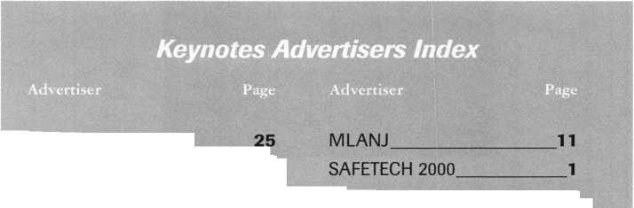

**Higher**

**Learning**

Last year, the ALOA Scholarship Foundation awarded 10 full convention package scholarships to ALOA ’99 in Cincinnati. Ask any one of those fortunate recipients and they’ll tell you it was a cost-effective and vital way of gaining even more knowledge that’s conducive to their career paths.

Don’t get left out of the mix this year. ALOA 2000 in Las Vegas will provide even more educational opportunities for locksmiths and security professionals. Make time NOW to complete the scholarship application form at the right.

If you’ve never been to an ALOA event, you don’t know what you’re missing. In addition to the selection of classes, there’s much to see and learn throughout the showroom floor.

You too can take advantage of one of our association’s most valued resources and learn more about different aspects of the trade. So what are you waiting for? The ALOA Scholarship Foundation is waiting to hear from YOU!

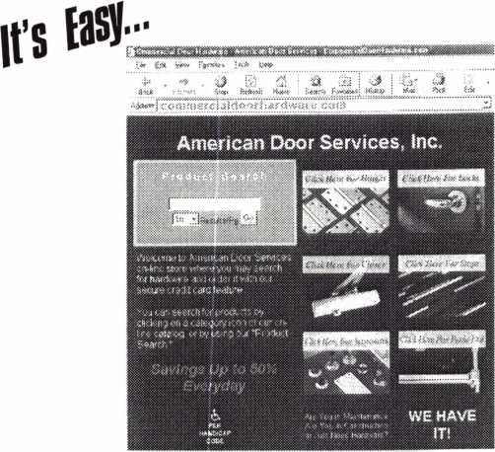

American Door Services, Inc. has opened an on-line catalog with secure credit card ordering offering commercial door hardware with savings up to 50% at all times. In our catalog, you will find hinges, locks, closers, stops, accessories and panic exit devices.

Just Type **. . .**

COMMERCIALDOORHARDWARE.COM

... in the address box

American Door Services, Inc. • (719) 477-5502 • Fax (719) 477-5503  
email: info @ commercialdoorhardware.com

|  |  |  |
| --- | --- | --- |
| 40 | Keynotes | January 2000 |
|  |  | |

Scholarships are awarded to those individuals who demonstrate their financial need and their desire for more education in the locksmithing field. If you or someone you know fits the above criteria, please fill out the application on this page and send or fax to the ALOA Office at 3003 Live Oak St., Dallas, Texas 75204 by the due date on February 1, 2000. The fax number is (214) 827-1810. Don’t forget to include your letter stating your reason for applying, your three letters of reference and your financial information. No late or incomplete applications will be considered.

ALOA SCHOLARSHIP FOUNDATION, INC.  
ALOA/SAVTA SCHOLARSHIP APPLICATION  
3003 Live Oak Street; Dallas TX 75204; (214) 827-1701

|  |  |  |  |
| --- | --- | --- | --- |
| Please print or type |  |  |  |
| NAME |  | PRP LEVEL | ALOA/SAVTA # |
| HOME ADDRESS | CITY | STATE | ZIP |

HOME PHONE,

DOB,

PRESENT EMPLOYER.

WORK ADDRESS

POSITION

EDUCATIONAL LEVEL {YEARS) DEGREE, IF ANY_

_ WORK PHONE- FAX

CITY.

STATE.

ZIP

□ FULL TIME □ PART TIME TAKE HOME PAY $_

LENGTH OF TIME IN LOCKSMITHING .

OWNER/SUPERVISOR’S FULL NAME

MEMBERSHIP IN TRADE ASSOCIATIONS (LIST BY NAME)_ MARITAL STATUS SPOUSE’S OCCUPATION _ COMBINED HOUSEHOLD ADJUSTED GROSS INCOME $_ CLASSES DESIRED

SPOUSE’S TAKE HOME PAY $_

NUMBER OF DEPENDENTS.

DATE OF CLASSES .

ORGANIZATION SPONSORING CLASSES: □ ALOA □ SAVTA □ OTHER (PLEASE NAME).

LOCATION

ALOA Scholarships are granted to selected individuals desirous of entering the locksmithing field or to selected individuals already in the locksmithing field who wish to improve their professional skills through education.

Applications for classes being taken locally must be received a minimum of 60 days prior to the date of the class, and will be reviewed as they are submitted. Scholarships for classes at the ALOA or SAVTA convention will be awarded each year at the ALOA Scholarship Foundation meeting preceding the convention and must be received by February 1 each year.

Please attach to this form a letter stating your reason for applying for a scholarship, what you plan to do with the knowledge you obtain and any other information you feel may be helpful to the scholarship board in making its decision. In addition, attach three let­ters of reference from individuals who have personal knowledge of your background and character. The letters should contain their names, addresses and phone numbers. It would be helpful if at least one of these references is an ALOA or SAVTA member. Also, please provide a copy of your most recent tax return.

All scholarship recipients will be required to provide a 3x5 inch photograph of themselves.

APPLICATION CHECK LIST

Only complete applications will be considered for scholarships. An application is considered incomplete unless ALL of the above requested information is received before the deadline: 60 days prior to the date of a class or February 1 for ALOA/SAVTA convention classes. Please send this application after checking off each of the below.

* I have filled in each blank on this form.
* I have written and enclosed a letter explaining my reason for applying.
* I have enclosed three letters of reference.
* I have enclosed a copy of my most recent tax return.
* I am submitting this in time to be received 60 days prior to the date of a class or by February 1 for ALOA/SAVTA convention classes.

CERTIFICATION OF APPLICANT:

I certify that the information contained herein, and all supplemental forms are complete and correct to the best of my knowledge. I further certify that if I am selected as a scholarship recipient I will use the knowledge gained for the improvement, development and advancement of the locksmithing profession.

Signature.

Date.

./.

January 2000

01/00

Keynotes141

Keynotes

Authors



Dept]

Donald B. Dennis, CPL has been dealing with the Locksmithing profession since 1972 with a four year apprenticeship in Albuquerque, New Mexico. He founded and has been the owner of Dennis Safe & Lock in

Johnson City, Tennessee since 1977. He was the founder of the East Tennessee Locksmith Association in 1988 and is currently the Chairman of the Education Committee and editor of ETLA Newsletter.

Marray Introduces... Factory Direct Prices

Electrified

Locks...as low as $142.00  
Hinges...as low as $64.80  
Panic bars...as low as $193.05  
Trim...as low as $270.00

WOW!!

Best Price Guaranteed!

What are you waiting for?

Call Marray Today  
1-800-500-1449

Marray. Your first source for UL listed & modified hardware.



Marray *enterprises, inc.*

**At Marray,** we’re not just modifiers, we’re Master Hardware Modifiers™  
1128 **Walsh Ave., Santa Clara, CA** 95050**. [www.marray.com](http://www.marray.com)**

VISA, MASTERCARD, COD. OPEN ACCOUNTS A.O.C.

I Sal Dulcamaro, CML, has

been in the locksmith business for over 24 years.  
He is the president of All Pro Security, Inc. in  
Michigan and has been an ALOA member for  
17 years. A past president of the Locksmith  
Security Association of Michigan. Sal currently  
serves as editor of the association newsletter. He  
was named "Keynotes Author of the Year” for  
1996 and 1997. He is also a contributing  
editor for Keynotes.

Billy B. Edwards Jr., CML is the Key Records Manager for Master Lock and the author of Master Keying by the Numbers. He is also the past recipient of the Philadelphia Award and serves as a Co-Chairman of the LIST Council.



Mike Eerrill is a third

generation locksmith, who lives on the Island of  
Nantucket in Massachusetts.



Tim McMullen oversees

legislative affairs for ALOA. He is a graduate  
of the District of Columbia School of Law and  
has an extensive background in legislative  
work.

Clint E. Pollard is executive vice president - marketing for The Yellow Pages Publishers Association (YPPA). Pollard began his Yellow Pages career with GTE Corporation in 1977. He became vice president of public affairs for GTE Directories Corporation in 1987; vice president marketing & communica­tions in 1988; vice president national accounts in 1994; and vice president!general manager west region in 1995.

Keynotes

January 2000

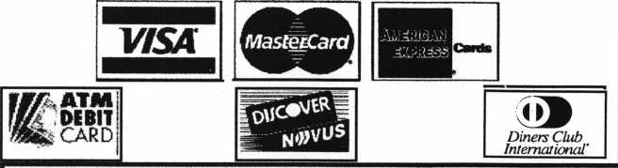

Accept Credit Cards  
and Increase Sales and Profits  
by 30% - 50%

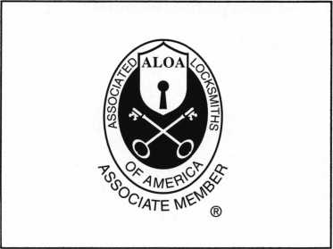

There are three reasons why people don’t accept credit cards:

Through Association Benefits **.** 1. Too expensive.

These Concerns Are Eliminated 2. The paperwork hassle.

~ ~ " ' I 3. Inability to qualify.

Here’s how it works: j

* Simply swipe or enter the credit card #.
* Enter amount of sale. No HftSSle - K»SV Qualifying
* Approval within seconds.
* Funds wired electronically into your local checking account within 48 hours.

Incredible News For Merchants  
Currently Accepting Credit Cards

Free Set Ud -*

£eceJV

No,

Because of your association membership, nearly 100% of all retail and home based applicants

will be approved even with past credit problems.

Currently Processing Merchants Please Read

Monthly Lease To Own Set-Up Options

Special Low Discount Rate and Transaction Fee: *1.59% + 20<t*Plus Monthly Statement!Customer Service Fee: *$10*

Package A: $29.95 Terminal

Package B: $39.95 Terminal & Printer In One  
Deluxe Package C: $49.95 Portable Terminal/Pnnter/Pin Rad  
Debit acess fee Ability to Accept Visa/MC “Check Cards”

$ 10/mo. & ATM Cards at a FLAT 2Sg

Totally Simulating the 1.59 % Rate  
(All lease terms 48 months • Monthly minimum $25)

**|** I authorize Universal’s sales office to print and deposit a check  
in the amount of $49 (normally $ 125) for my application fee which

covers initial materials, application processing, equipment warranty,

shipping & handling, programming, installation and training.

* Fill out a check, tape here above mini form and then fax.

Fax Express Mini Form Now To **1 -800-439-7773**

.vwceive a Free Pin Pad 4^^

& Himinate Your Percentage Rate on all Visa/MC Checkcaids (which is normally 1/3 of the credit cards processed).

You pay ONLY 25tf flat per The oper^

.sss-

^ccep

m i£*>cani

"Kcbaa,

rPert

f and

|ged.

(and

^ired

accept t

SAVE UP TO 35%

IN CREDIT CARD

'Seer*”-'

JOB

■low)

Company Name.

Contact Name

Address

City

State-

Zip.

Phone

Best Time

Signature

New Account Set-up Options (Check)

n

Package A 1—1 Package B □

Deluxe Package C I—I

Free Pin Pad Program For Currently Processing Merchants □

A subsidiary of Universal Savings Bank, F.A

Marketing Office 1-800-836-4295

Universal Payment Processing Provides **24** Hour Live Customer Service.

Dept



Page

**The envelope,**

**please...**

Yes, it’s that time again. Time to start thinking about your favorite Keynotes articles and decide who should be Author of the Year for 1999-2000.

We’ll soon run a ballot and a list of articles and authors, so you can cast your vote!

Past winners have included Sal Dulcamaro (’96, ’97) Paul Chandler (’98) and Dan Graffeo (’99).

Your vote is very important, so start thinking about the articles you feel are the most informative, entertaining and educational! Also, think about the authors who you feel touch on subjects important to you and your business!

For more details, write:

**Keynotes** Author of the Year

3003 Live Oak Dallas, TX 74204 (214) 827-1810 fax [keynotes@anet-dfw.com](mailto:keynotes@anet-dfw.com)

**44 [** Keynotes **January 2p(>0**

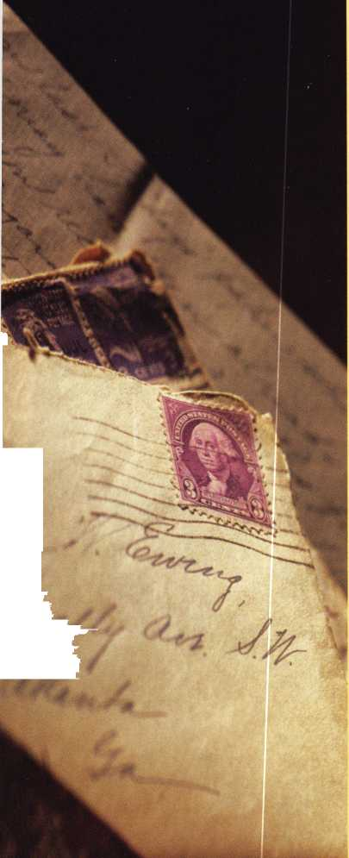

D extend my subscription to Locksmith Ledger International

Please

**the Security Professional**

' OPENING A WORLD OP OPPORTUNITIES

HE

I

□ 3 YEARS (includes 36 issues, 3 FREE Annual Directory* issues)

USA $90.00

J 2 YEARS (includes 24 issues, 2 FREE Annual Directory* issues)

USA $64.00 Canada $93.00 International (air) $185.00 International (surface) $119.00

J 1 YEAR (includes 12 issues, 1 FREE Annual Directory* issue)

USA $41.00 Canada $52.00 International (air) $100.00 International (surface) $65.00

•Comprehensive guide to industry manufacturers, distributors, products and services.

**CARD INVALID UNLESS COMPLETE DATA IS GIVEN**

You must indicate your iocksmithing affiliation below:

1. Are you a locksmith or an individual involved in Iocksmithing? Qyes Qno
2. Your position is: QOwner/Pres. 3 Employee (3 Student 3 Other (specify)

3 Business classification (check one only): a QLocksmith Shop b QHardware c Q Wholesaler/Distributor d Q Manufacturer e □ Security or Maintenance

1. Q Consultant 3 Q Industrial sQ Government
2. Q Commercial 4 Q Institutional 6 Q Police

g Q Architect/Specifier z Q Other (specify)

4. Are you involved in purchasing or influencing the purchase of locksmith products?

□yes Qno

Name:

Company:

Address:

City:State: 2ip:

Phone:Fax:

Payment (US FUNDS ONLY): □ Money order □ChargeCard □Check#:

Complete For Charge Orders Only: QVISA □Master Card □American Express Account # :Exp. Date:

Send payment to: Locksmith Publishing Corp. • 850BusseHwy. • Park Ridge, IL 60068 • Phone:(847)692-5940 • Fax (847) 692-4604 • Website: [www.lpc.simon-net.com](http://www.lpc.simon-net.com)

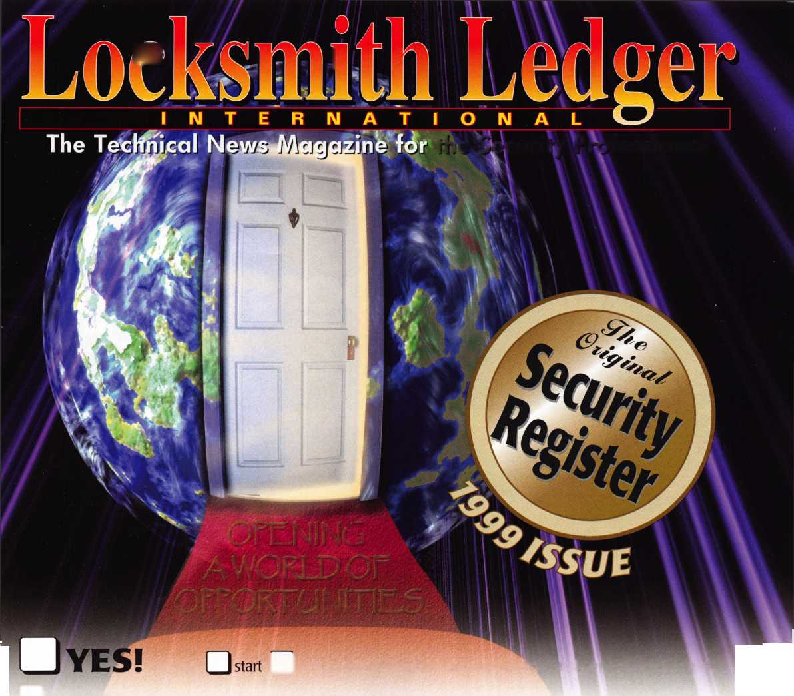

**This opens up**

ISOProx® II

**Cypress**

**Computer**

**Systems**

**Ilco Unican**

**Locknetics**

**a world of possibilities.**

Introducing the ePROX™Lock Module j~ only from HID.

Now the security and reliability of proximity access is available in standard electronic locks. It’s battery-powered for stand-alone applications, and, using the same HID card or keyfob, it can

eProx™

Lock technology I available from:

**Alarm Lock**

easily augment an  
existing on-line access  
control system.With  
HID battery-powered  
proximity, the one card

solution becomes a simple and  
economical reality. The ePROX™  
Lock Module from HID. Proximity  
access has finally arrived at your door.

[www.hidcorp.com](http://www.hidcorp.com)

Copyright 1999 HID Corporation

We identify with your business. •

(800) 23 7-PROX (7769) HID CORPORATION

